My Notes - Stanford Algorithms Design Part 1

# 01 - Week 01 – Introduction

## 01 - 1 - Why Study Algorithms

First, understanding the basics of algorithms, and the related field of data structures, is crucial for doing serious work in almost any other branch of computer science.

A few examples:

* Routing and communication networks piggyback on classical shortest path algorithms.
* The effectiveness of public key cryptography relies on that of number-theoretic algorithms.
* Computer graphics need the computational primitives supplied by geometric algorithms.
* Database indices rely on balanced search tree data structures.
* Computational biology uses dynamic programming algorithms to measure genome similarity.

Secondly, it is brain stimulating fun!

## 01 - 2 - Integer Multiplication (9 min)

In this course lectures follow a pattern:

* Define computational problem: Input, desired output.
* Give solution.

Integer Multiplication

* Input: 2 n-digit numbers x and y
* Output: product x*y
* “Primitive Operation” – add or multiply 2 single-digit numbers.



Grade-School Algorithm (Integer Multiplication)

Notes:

To compute each row – e.g. 22,712 – we did multiplied each digit times 4 and did carries where needed. This comes down to ≤ 2n operations (per row). Do this for n rows – you get ≤operations. To complete the job, we have to add the partial values – taking a comparable number of operations – i.e. add another ≤– leaving us with .

**Upshot (future focus point):** the number of operations grows like .

**The Algorithm Designer’s Mantra**

* “Perhaps the most important principle for the good algorithm designer is to refuse to be content.”

- Aho, Hopcroft, and Ullman,  *The Design and Analysis of Computer Algorithms*, 1974

* “Can we do better?”

## 01 - 3 - Karatsuba Multiplication (13 min)

Example (same two numbers from previous section):



1. Compute: 
2. Compute: 
3. Compute: 
4. Compute: 
5. Pad ‘1’ with 4 zeroes. Pad ‘4’ with 2 zeroes. Add these with ‘2’:



**A Recursive Algorithm:**

Rewrite x and y (n digit numbers) by dividing them up and representing them as combinations of a,b,c,d ( digit numbers).



Then:



Idea: recursively compute ac,ad,bc,bd, then compute (*) in the straight forward way.

Karatsuba Multiplication:

1. ac (the left-side value)
2. bd (right right-side value)
3. (a+b)(c+d)=ac+ad+bc+bd
4. Gauss’s trick: ‘3’-‘1’-‘2’ = ad+bc (the middle value)

Upshot: only need 3 recursive multiplications (Steps 1-3) on smaller numbers ! (and some additions).

Note: For defining a recursive algorithm, we need to define a base case. Here the base case would be multiplication of single digit numbers.

## 01 - 4 - About the Course (17 min)

Course Topics

* Vocabulary for design and analysis of algorithms
* Divide and conquer algorithm design paradigm
* Randomization in algorithm design
* Primitives for reasoning about graphs
* Use and implementation of data structures
* *Excellent free reference: “*Mathematics for Computer Science”, by Eric Lehman and Tom Leighton. (Easy to find on the Web.)

A few good books:

* + Kleinberg/Tardos, *Algorithm Design*, 2005.
  + Dasgupta/Papadimitriou/Vazirani, *Algorithms*, 2006.
  + Cormen/Leiserson/Rivest/Stein, *Introduction to Algorithms*, 2009 (3rd edition).
  + Mehlhorn/Sanders, *Data Structures and Algorithms: The Basic Toolbox*, 2008.

## 01 - 5 - Merge Sort_ Motivation and Example (9 min)

Why study Merge Sort?

* Good introduction to divide & conquer
  + Improves over Selection, Insertion, Bubble sorts
* Motivates guiding principles for algorithm analysis (worst-case and asymptotic analysis)
* Analysis generalizes to “Master Method”

**Notes:**

* Selection sort – repeatedly identify minimum from i to n and push it to position i.
* Insertion sort – repeatedly maintain the invariant: a prefix sorted view from 0 up to i.
* Bubble sort – repeatedly bubble up (swap two elements)

The Sorting Problem:

Input: array of n numbers, unsorted. (assume distinct)



Output: same numbers, sorted in increasing order.

**Merge Sort: Example**



## 01 - 6 - Merge Sort_ Pseudocode (13 min)

**Merge Sort: Pseudo code**

* Recursively sort 1st half of the input array
* Recursively sort 2nd half of the input array
* Merge two sorted sublists into one
* [ignores base cases – 1 or 0 elements are already sorted, odd number of elements – e.g. break 9 elements into 4 and 5, skipping recursiveness details – e.g. how to pass subarrays onto the recursive calls]

C**=**output **[**length**=**n**]**

A**=**1st sorted array **[**n**/**2**]**

B**=**2nd sorted array **[**n**/**2**]**

i **=** 1

j **=** 1

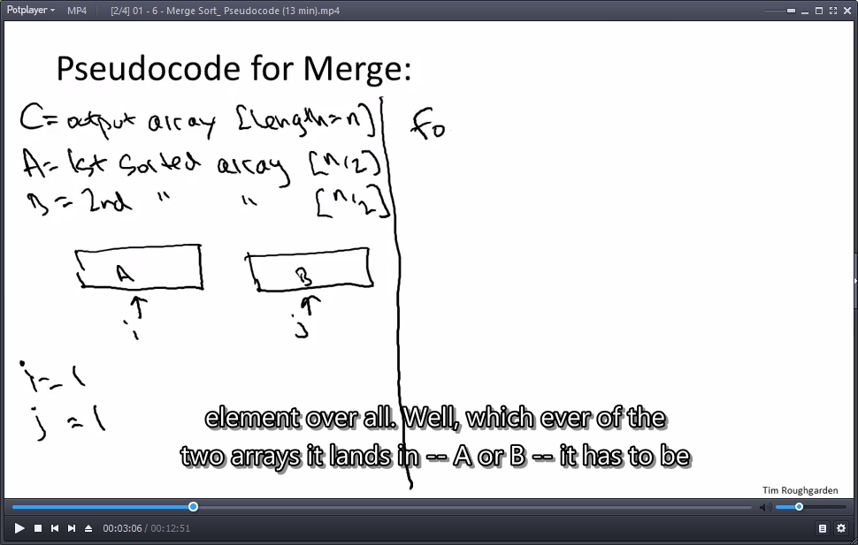

*/** merge sorted sub-arrays into C[] **/*

**for** k **=** 1 to n

**if** A**(**i**)** **<** B**(**j**)**

C**(**k**)** **=** A**(**i**)**

i**++**

**else** **[**B**(**j**)** **<** A**(**i**)]**

C**(**k**)** **=** B**(**j**)**

J**++**

end

**(**ignores end cases where we “fall off” A[] and B[] and copy the leftover values from the other array**)**

Merge Sort Running Time?

Initialization: i=1,j=1 – 2 operations.

For loop: n times.

* For loop iteration: one check of the loop condition (should I step in the loop?), one comparison A()<B(), 2 more operations (Assign and increment) – 4 operations.

Upshot: at most, merge operation takes .

**Claim:** Merge Sort requires  operations to sort n numbers.

Recall:  is the # of times you divide n by 2 to get down to 1. E.g. .

## 01 - 7 - Merge Sort_ Analysis (9 min)

**Claim:** Merge Sort requires no more than  operations to sort n numbers.

Proof of claim (assuming n = power of 2):



Binary tree representation for a Merge Sort analysis.

Note: level 0 – entire input , level 1 – Left and Right halves.

What is the number of levels in the tree?

* 

Note: analysis can easily extend to cases where n is not a power of 2.



Let’s recognize the pattern:

* How many sub-problems:
  + Level j has  sub-problems.
* What is the input size:
  + Level j sub-problem has input of size  .

At each level j=0,1,2,…,:

* Total # of operations 



Note:  us cancelled out in each level.

* The Competing forces:
  + number of subproblems – doubling
  + amount of work per sub-problem – cutting in half

## 01 - 8 - Guiding Principles for Analysis of Algorithms (15 min)

Guiding Principles:

1. use ‘worst case’ analysis.
   1. No assumptions on the input, where it comes from or how it looks like.
   2. As opposed to “average-case”/benchmarks – requires domain knowledge.
   3. Bonus: worst case usually easier to analyze.
2. Won’t pay attention to constant factors, lower-order terms.
   1. Easier.
   2. Constants change per architecture/compiler/programmer anyway.
   3. Lose little predictive power.
3. Asmptotic Analysis: focus on running time for large input sizes n.
   1. E.g.  better than  (only after you pass n=90)



Once you get to large numbers….



# 02 - Week 01 - Asymptotic Analysis

## 02 - 1 - The Gist (14 min)

The gist of Asymptotic Analysis

**High-level idea:** suppress constant factors and lower-order terms.

**Example:** we go from the Merge Sort upper limit  to .

A few examples for use of Big-Oh notation:

1. Run from i=0 to n-1, if value is positive return True. End loop. Return False.
   1. Runtime (One loop) -  - linear time
2. Same as ‘1’, only 2 consecutive loops.
   1. Runtime (Two consecutive loops) - 
3. Run 2 nested loops – indicies i,j – look for common number (brute force).
   1. Runtime (Two nested loops) -  - quadratic time
4. Does array A have duplicate entries? – for item ‘i’, run from i+1 to n-1 and look for duplicates (brute force search)
   1. Runtime (Two nested loops, inner loop gets linearly smaller with each iteration):

- 

## 02 - 2 - Big-Oh Notation (4 min)

Big-Oh: Formal Definition:



There exists c, n0 such that for every n greater or equal to n0 the runtime is bound by c times the function.

**Warning:**  cannot depend on . I.e. when you choose c, n0, they cannot include the variable n.

## 02 - 3 - Basic Examples (7 min)

Big-Oh basic examples:

**Example 1:**

* Claim: if  then  .
* Proof: Choose  and  .
* Need to show that 
* We have, for every  ,
* 

**Example 2:**

* Claim: 
* Proof: by contradiction. Suppose .
* Then: 
* But (cancelling  from both sides):
* You get:  - clearly false.
* [contradiction]

## 02 - 4 - Big Omega and Theta (7 min)

Big Oh relatives Omega and Theta:

* Omega:  (greater in behavior)
* Theta:  (between in behavior)
  + Equivalent: 

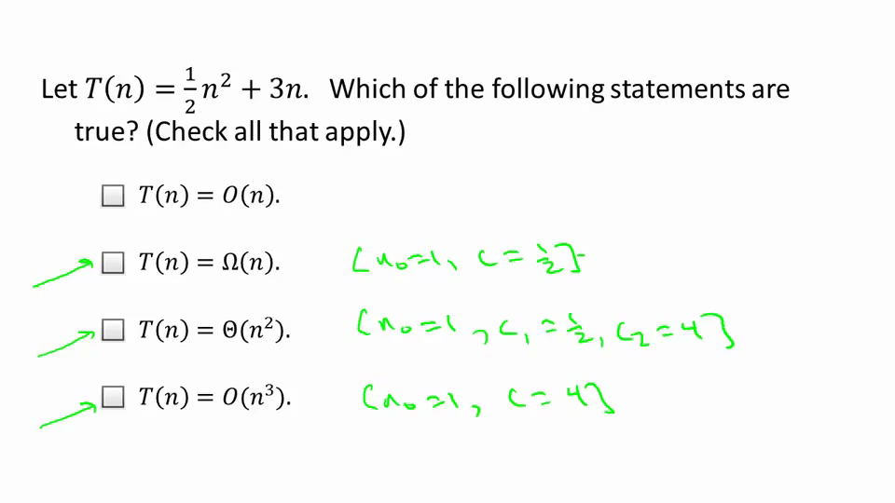

Little-Oh (stronger than Big-Oh):



Example: 

Proof: if  , then 

## 02 - 5 - Additional Examples [Review - Optional] (8 min)

Example 1:

* **Claim:** 
* **Proof:** pick constants so that 
* Choose: 

Example 2:

* **Claim: **
* **Proof:** by contradiction.
* If 

Example 3:

* **Claim:** for every pair of (positive) functions f(n), g(n), 



* **Proof:**
* 

# 03 - Week 01 – Divide and Conquer Algorithms

## 03 - 1 - O(n log n) Algorithm for Counting Inversions I (13 min)

**The problem (counting inversions):**

* Input: array A containing the numbers 1,2,3,…,n in some arbitrary order
* Output: number of inversions = number of pairs (i,j) of array indices with i<j and A[i]>A[j].

**Examples and Motivation:**

* Example: 
* Inversions: (3,2), (5,2), (5,4)
* Motivation: numrical similarity measure between two ranked lists

E.g. for collaborative filtering (recommendations based on similar lists)



What is the largest-possible number of inverstions in a 6-element array?

6 choose 2:  - for n-elements: 

**High-Level Approach:**

* Brute-force:  (double for loop) - Can we do better? Yes!
* Key Idea 1: Divide and Conquer

Call an inversion (i,j) [with i<j]

* Left: if i,j < n/2 (left inversion)
* Right: if i,j > n/2 (right inversion)
* Split: if i ≤ n/2 < j (split inversion)

Note: ‘left’ and ‘right’ can be computed recursively, while ‘split’ requires a separate subroutine.

Base case: One element array.

Count **(**array A**,** length n**)**

**if** n**=**1**,** **return** 0

**else**

x**=**Count**(**1st half of A**,** n**/**2**)**

y**=**Count**(**2nd half of A**,** n**/**2**)**

y**=**CountSplitInv**(**A**,**n**)**

**return** x**+**y**+**z

Goal: implement CountSplitInv() in linear time . Then, Count will run in .

Can we really count a quadratic number of items in linear time? Yes.

## 03 - 2 - O(n log n) Algorithm for Counting Inversions II (17 min)

**Issue addressed:**

We have the idea of splitting the array. The problem is the inversions that are not on the same side – aka ‘split inversions’. There could be a quadratic amount of these, but we’d like to be able to count them in linear time.

**Piggybacking on Merge Sort:**

* Key Idea 2: have recursive calls count inversions *and* sort.
* Motivation: Merge subroutine naturally uncovers split inversions [as we’ll see]

**High-Level Algorithm (revised):**

Sort_and_Count **(**array A**,** length n**)**

**if** n**=**1**,** **return** 0 ***// base case, array of length 1***

**else**

**(**B**,**x**)=**Sort_and_Count**(**1st half of A**,** n**/**2**)** ***// B=sorted 1st half***

**(**C**,**y**)=**Sort_and_Count**(**2nd half of A**,** n**/**2**)** ***// C=sorted 2nd half***

**(**D**,**z**)=**Merge_and_CountSplitInv**(**B**,**C**,**n**)** ***// D=sorted A***

**return** x**+**y**+**z

Goal: implement CountSplitInv() in linear time . Then, Count will run in .

**Some intuition:** why does merge-sort naturally uncovers the number of split inversion?

**Pseudocode for Merge:**

D **=** output **[**length **=** n**]**

B **=** 1st sorted array **[**n**/**2**]**

C **=** 2nd sorted array **[**n**/**2**]**

i**=**1

j**=**1



**for** k **=** 1 to n

**if** B**(**i**)** **<** C**(**j**)**

D**(**k**)** **=** B**(**i**)**

i**++**

**else** **[**C**()**J**)** **<** B**(**i**)]**

D**(**k**)** **=** C**(**i**)**

j**++**

end ***// ignores end cases***

**Intution explained:** in the merging part of the merge-sort, we see every inverted pair when an item from subarray C is smaller than an item in subarray B (see diagram above).

More accurately, when C[j] is smaller than B[i], all items left in B are ‘split inversions’ of C[j].

**Example:**

* Input: B = 1,3,5 ; C = 2,4,6
* Output: 1,2,3,4,5,6
* When 2 is copied from C to the output, we discover split inversions (3,2) and (5,2)
* When 4 is copied from C to the output, we discover split inversion (5,4)

Claim: the split inversions involving an element y of the 2nd array C are precisely the numbers left in the 1st array B when y is copied to the output D.

Proof: x is an element of B.

1. If x copied to output D before y, then x<y: no inversions involving x and y.
2. If y copied to output D before x, then y<x: x and y are (split) inversion).

**Merge_and_CountSplitInv:**

* While merging two sorted subarrays, keep running total of number of split inversions
* When element of 2nd array C gets copied to output D, increment total by number of elements remaining in 1st array B.

Runtime of subroutine: 

 Sort_and_count() runs in  time [just like Merge Sort].

## 03 - 3 - Strassen_'s Subcubic Matrix Multiplication Algorithm (22 min)

**Matrix Multiplication**



* For every element in Z: 
* Thus: 

**Divide, Conquer, Combine:**

Idea:



Note: A,B,C,…,H are n/2 by n/2 matrices.

Then:



Notes:

* These “products” are n/2 by n/2 matrices.
* Matrix block multiplication behaves as though blocks were atomic elements.

**Recursive Algorithm 1:**

* Step 1: recursively compute the 8 products.
* Step 2: do the necessary additions ( runtime)
* Fact: runtime is still cubic time. We need a super-trick.

**Strassen’s Algorithm (1969) – Matrix Multiplication:**

* Step 1: recursively compute 7 (super clever) products.
* Step 2: do the necessary (clever) additions and subtractions (still  runtime)
* Fact: better runtime than cubic time!

**The details:**

* Seven products:



* Claim:



* Proof:
* 
* The others can be done as well.

**Aymptotic complexity:**

* 

## 03 - 4 - O(n log n) Algorithm for Closest Pair I [Advanced - Optional] (32 min)

**The Closest Pair Problem – computational geometry**

* Input: a set  of n points in the plane  .
* Notation:  = Euclidean distance



* Output: a pair  of distinct points that minimize d(p,q) over p,q in the set P.
  + I.e. outputs the two closest points in the set.

**Initial Observations:**

* Assumption: (convenience) all points have distinct x-coordinates, distinct y-coordinates.
* Brute force search: takes  time.
* 1-D Version of Closest Pair:
  1. Sort points -
  2. Return closest pair of adjacent points - 
* Goal:  time algorithm for 2-D version.

**High-Level Approach – Closest Pair:**

1. Make copies of points sorted by x ( ) and y ( ) - 

Note: not enough yet – 6 point example:



Close x coordinates doesn’t guarantee closest distance (blue dots).

1. Use Divide+Conquer (+Combine)

**ClosestPair(Px,Py) – first look**

1. Let 

Form  (divide pre-sorted Px,Py to left and right) - 

1. (p­­1,q1)=ClosestPair(Qx,Qy)
2. (p­­2,q2)=ClosestPair(Rx,Ry)
3. (p­­3,q3)=ClosestSplitPair(Px,Py)
4. Return best of (p­­1,q1), (p­­2,q2), (p­­3,q3)

* Note: base case – 2-3 points – omitted.

If we can correctly implement ClosestSplitPair() in , overall runtime would be .

Key Idea: only bother computing ClosestSplitPair() in “unlucky case” where its distance is less than d(p­­1,q1) and d(p­­2,q2) – (the results of ‘2’ and ‘3’).

**ClosestPair(Px,Py) – including δ=min(‘2’,’3’)**

1. Let 
   1. Form  (divide pre-sorted Px,Py to left and right) - 
2. (p­­1,q1)=ClosestPair(Qx,Qy)
3. (p­­2,q2)=ClosestPair(Rx,Ry)
4. Let 
5. (p­­3,q3)=ClosestSplitPair(Px,Py,δ)
6. Return best of (p­­1,q1), (p­­2,q2), (p­­3,q3)

Notes:

* base case – 2-3 points – omitted.
* ClosestSplitPair() requires  time.
* ClosestSplitPair() requires correctness when closest pair of P is a split pair.

**ClosestSplitPair(Px,Py,δ)**

* Let  = biggest x-coordinate in left of P –  time
* Let  = points of P with x-coordinate in ,

sorted by y-coordinate –  time (linear scan through Py)

* Initizlize best=δ, best pair=Null

ClosestSplitPair(px,py,delta)

/*

x_tag = biggest x-coordinate in left of P

Sy = points of P sorted by y with x coordinates in special area

*/

// initialize

best=delta; best_pair=NUll

for i= 1 to rank(Sy)-1

for j= 1 to min{7,rank(Sy)-i}

let p,q= ith, (i+j)th points of Sy // up to seven spots apart on the sorted Sy set

if d(p,q) < best // compare points with 'best' (default=delta)

best_pair = (p,q), best = d(p,q) // new best pair (is a split pair)

Notes:

* For j= 1 to min{7,rank(Sy)-i} (max 7 runs) – takes 
* For i= 1 to |Sy|-1 (review all points in Sy) – takes 

**Correctness Claim:**

* Claim: Let  be a split pair with d(p,q)<δ (min{‘1’,’2’})
* Then:
  1. p and q are members of Sy
  2. p and q are at most 7 positions apart in Sy
* Corollary 1: If the closest pair of P is a split pair, then the ClosestSplitPair finds it.
* Corollary 2: ClosestPair is correct, and runs in  time.

## 03 - 5 - O(n log n) Algorithm for Closest Pair II [Advanced - Optional] (19 min)

**Proof of Correctness Claim (01):**

* Let 

Note: Since 

* p,q are a split pair with d≤δ. 
* Ergo: 



**Proof of Correctness Claim (02):**

*  are at most 7 positions apart in  .
* Key Picture: draw  boxes with center  and bottom  .



* Lemma 1: all points of Sy with y-coordinate between those of p and q, inclusive, lie in one of these 8 boxes.



* Proof:
  1. Recall y-coordiantes of p,q differ by < δ.
  2. By Sy definition, all have 
* Lemma 2: at most one point of P in each box.
* 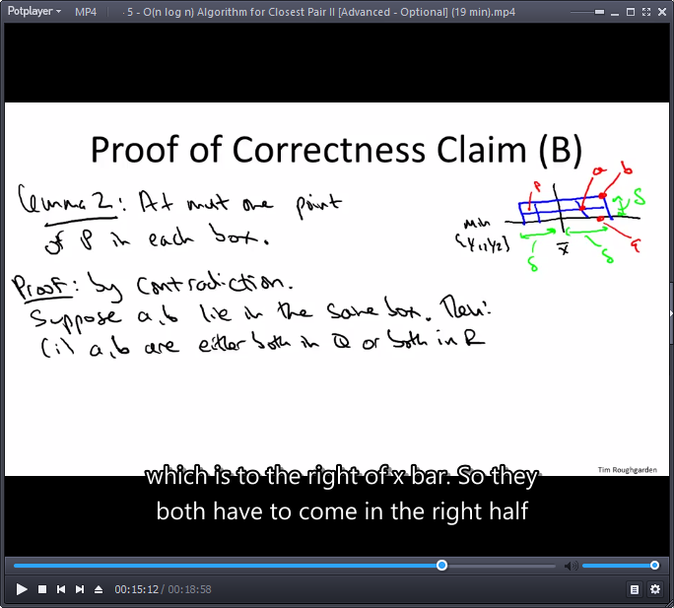Proof: by contradiction, suppose a,b lie in the same box.
* Then:
  1. a,b are either both in Q or both in R
  2. 
* But ‘01’ and ‘02’ contradict the definition of δ (smallest distance of pairs within Q or R).
* QED

**Final Wrap-Up**

Lemmas 1 and 2 => at most 8 points in this picture (including p and q)

* Positions of p,q in Sy differ by at most 7.

## Problem Set-1

<https://class.coursera.org/algo-009/quiz>

### Question 1

3-way-Merge Sort : Suppose that instead of dividing in half at each step of Merge Sort, you divide into thirds, sort each third, and finally combine all of them using a three-way merge subroutine. What is the overall asymptotic running time of this algorithm? (Hint: Note that the merge step can still be implemented in *O*(*n*) time.)

*n*log(*n*) - **ex:**  levels, each level j has 

*n*2log(*n*)

*n*(log(*n*))2

*n*

### Question 2

You are given functions *f* and *g* such that *f*(*n*)=*O*(*g*(*n*)). Is *f*(*n*)∗*log*2(*f*(*n*)c)=*O*(*g*(*n*)∗*log*2(*g*(*n*))) ? (Here *c* is some positive constant.) You should assume that *f* and *g* are nondecreasing and always bigger than 1.

Sometimes yes, sometimes no, depending on the constant *c*

True

False

Sometimes yes, sometimes no, depending on the functions *f* and *g*

**Ex:**

1. 
2. 
3. Assume yes.
4. Then:



### Question 3

Assume again two (positive) nondecreasing functions *f* and *g* such that *f*(*n*)=*O*(*g*(*n*)). Is 2^*f*(*n*)=*O*(2^*g*(*n*)) ? (Multiple answers may be correct, you should check all of those that apply.)

Yes if *f*(*n*)≤*g*(*n*) for all sufficiently large *n*

Always - What if f(n) = 2n and g(n) = n? 

Sometimes

Never

**Ex:**

1. 
2. 
3. 
4. 

### Question 4

k-way-Merge Sort. Suppose you are given *k* sorted arrays, each with *n* elements, and you want to combine them into a single array of *kn* elements. Consider the following approach: Using the merge subroutine taught in lecture, you merge the first 2 arrays, then merge the 3*rd* given array with this merged version of the first two arrays, then merge the 4*th* given array with the merged version of the first three arrays, and so on until you merge in the final (*kth*) input array. What is the running time taken by this successive merging algorithm, as a function of *k* and *n*? (Optional: can you think of a faster way to do the k-way merge procedure ?) **Ex:** use linear min{A1,A2,…,Ak} implementation and advance indices.

*θ*(*nk^*2)

*θ*(*n*log(*k*))

*θ*(*n^*2*k*)

*θ*(*nk*)

**Ex: **

### Question 5

Arrange the following functions in increasing order of growth rate (with *g*(*n*) following *f*(*n*) in your list if and only if *f*(*n*)=*O*(*g*(*n*))).  
  
a)2^log(*n*)  
b)2^2^log(*n*)  
c)*n^*5/2  
d)2^*n^*2  
e)*n^*2log(*n*)  
Write your 5-letter answer, i.e., the sequence in lower case letters in the space provided. WARNING: this question has multiple versions, you might see different ones on different attempts!

**Ex:**



Aecbd

### Question 5 – take 2:

a)*n^*2log(*n*)  
b)2^*n*  
c)2^2^*n*  
d)*n^log*(*n*)  
e)*n^*2

**Ex:**



## Programming Question-1

<https://class.coursera.org/algo-009/quiz?quiz_type=homework>

### Question 1

Download the text [file here](http://spark-public.s3.amazonaws.com/algo1/programming_prob/IntegerArray.txt). (Right click and save link as) This file contains all of the 100,000 integers between 1 and 100,000 (inclusive) in some order, with no integer repeated.

Your task is to compute the number of inversions in the file given, where the ith row of the file indicates the ith entry of an array.

Because of the large size of this array, you should implement the fast divide-and-conquer algorithm covered in the video lectures.

**Answer:**

<https://github.com/OferSheffer/Review_Stanford_Algorithms/tree/master/src/P01W01Q01>

# 04 - Week 02 - The Master Method

## 04 - 1 - Motivation (8 min)

Example: The recursive algorithm for multiplication (Lecture 01.3)



* Algorithm 1:
  1. 
* Algorithm 2 (Gauss):
* Recursively compute **(1)** ac, **(2)** bd, **(3)** (a+b)*(c+d) [recall ad+bc=’3’-‘1’-‘2’]
  1.  - we don’t yet know how to compute the runtime here.

Example: Merge-Sort

* 1.  - even better.

## 04 - 2 - Formal Statement (10 min)

**The Master Method: Recurrence Format**

Assumption: all subproblems have equal size.

1. Base Case:  for sufficiently small n.
2. All larger n: 
   1. 
   2. 

factor by which the input size shrinks before we recurse.

* 1. 

exponent in the amount of work done outside the recursive call.

[a,b,d independent of n]

**The Master Method**



**Notes:**

* Case 1: base doesn’t matter on the ‘log(n)’ (only changes leading constants)
* Case 3: base ‘b’ DOES matter on the ‘log{b}{n}’

## 04 - 3 - Examples (13 min)

**Example 1: Merge-Sort**



**Example 2: Binary search in a sorted array**



**Example 3: Integer Multiplication Algorithm 1**



**Example 4: Gauss’s recursive integer multiplication algorithm**



**Example 5: Strassen’s Matrix Multiplication Algorithm**



**Example 6: Fictitious Recurrence**



**Note:** external work dominates the runtime.

## 04 - 4 - Proof I (10 min)

**The Master Method**



**Preamble**

Assume: reccurence is (for some constant c)

1. 
2. 

**And** n is a power of b. (general case is more tedious)

Idea: generalize MergeSort analysis (use a recursion tree).

* Each level j=0,1,2,… has  subproblems.
* Each subproblem on level j is of size .



**Work at a Single Level:**

Total work at level j [ignoring work in recursive calls]:



**Total Work:**



## 04 - 5 - Interpretation of the 3 Cases (11 min)

**How to think About (*):**

* Upper bound for work at level j:
* 

Interpretation

* A tug of war between two opposing forces (good and evil):
* a = rate of subproblem proliferation (RSP)
* bd = rate or work shrinkage per subproblem (RWS)
  1. b shrinks the problem size, d determines the amount of work.



**Intuition for the 3 Cases:**

1.  - same amount of work each level.
2.  - less work each level (most work at the root)
3. - more work each level, most work at the leaves.

## 04 - 6 - Proof II (16 min)

**So Far/Case 1:**

Total work:  [Case 1]

**Basic Sums Fact:**

For 

* Another proof: 

Upshot:

1. If r<1:  - 1st term of the sum dominates
2. If r>1:   - last term of the sum (r^k) dominates

**Case 2:** Work dominated by top level

Total work:  [Case 2]

**Case 3:** Work dominated by the lognn leaves

Total work:  [Case 3]

**Note:**  (level j has aj leaves, last level has j=logbn)

**The Master Method**



# 05 - Week 02 - Quicksort – Algorithm

## 05 - 1 - Quicksort_ Overview (12 min)

**Quicksort**

* Useful, elegant, “greatest hit” algorithm with  time “on average”.
* Works ‘In Place’, without the use of much extra memory.

**The Sorting Problem – same as in Merge Sort**

* Input: array of n numbers, unsorted
* Ex. 3 8 2 5 1 4 7 6
* Output: same numbers, sorted in increasing order
* Ex. 1 2 3 4 5 6 7 8
* Assume: all array entries distinct (no duplicate values)

Exercise: extend QuickSort to handle duplicate entries.

**Partitioning Around a Pivot:**

* Key Idea: partition array around a pivot element.
* Bucket values and rearrange array so that
  1. Left of pivot => less than pivot
  2. Right of pivot => greater than pivot
* Note: puts pivot in its “rightful position”.

**Two Cool Facts about Partition:**

1. Linear time to partition with no extra memory use.
2. Reduces problem size (we make progress with the ‘sorting problem’)

**QuickSort: High-Level Description:** [Tony Hoare circa 1961 (Turing Award winner 1980)]

QuickSort(array A, length n)

 If n=1 return

p = ChoosePivot(A,n)

Partition A around p

Recursively sort 1st part

Recursively sort 2nd part

**Note:** in merge sort, we recurse and merge. Here, recursion comes last, after we partition with the pivot being placed in its rightful place. There is no merge step.

## 05 - 2 - Partitioning Around a Pivot (25 min)

**The Easy Way Out – Partition using a second array (extra O(n) memory):**



Using extra memory – the easy n00b way out

**In-Place Implementation:**

* Assume: pivot = 1st element [if not, swap chosen pivot with the 1st element]
* High-Level Idea:



Smaller than p comes first, bigger comes last.

* Single scan through array
* **Invariant:** everything looked at so far is partitioned.

**Partition Example:**



* Note: to get linear runtime we’d like to advance j to look at one new element each step.

1. Everything is unpartitioned. Both i and j point to [1], after the pivot (3).
2. Looking at the first element after (3), the 8 is entered into the “bigger than” partitioned segment. I.E. j needs to be pushed after its position to [2]. Next item (increase j one more), (2) is smaller than the pivot (3) and needs to be put at the beginning (swap with the 8).
3. Advance i to point at the position where (3) would fit.
4. Advance j again to look at the (5), it is bigger than the pivot. We do nothing further.

Continued…

1. Advance j again to include (1). Smaller than the pivot, we swap it with the first element in the “bigger than” partition (swap [j] with position [i]).
2. Advance I to show the “smaller than [pivot]” partition includes a new value.
3. Continue same procedure i stays put while j reaches the end of array.
4. Swap last element in “smaller than” group [i-1] with pivot [0].

**Pseudocode for Partition:**

Partition**(**A**,** l**,** r**)**

"""

Array A, l Left boundary, r Right boundary

Input: A[l:r]

"""

p **=** A**[**l**]**

i **=** l**+**1

 **for** j**=**l**+**1 to r**:**

**if** A**[**j**]** **<** p**:** ***# if A[j] > p, do nothing***

swap A**[**j**]** **and** A**[**i**]**

i **+=** 1

swap A**[**l**]** **and** A**[**i**-**1**]**

**Running Time:**

*  work per array entry.
*  partition runtime, where  is the length of the input.
* Bonus: works in place (no need for a lot of extra memory)

**Correctness:**

* Claim: for loop maints the invariants
  1. A[l+1],…,A[i-1] less than pivot
  2. A[i],…,A[j-1] greater than pivot
* Consequence: end of loop maintains pivot at [0], “smaller than” at (1:i), “bigger than” at (i:j) and after the final swap, the array is partitioned around the pivot. QED.

## 05 - 3 - Correctness of Quicksort [Review - Optional] (11 min)

**Induction Review:** reminder how to do induction

* Let P(n) = assertion parameterized by positive integers n.
* For us: P(n) is “Quick Sort correctly sorts every input array of length n”

How to prove P(n) for all n >= 1 by induction:

1. [base case] directly prove that P(1) holds.
2. [inductive step] for every n>=2, prove that:

If P(k) holds for all k<n, then P(n) holds as well.

**Correctness of QuickSort:**

* P(n) = “QuickSort correctly sorts every input array of length n”
* Claim: P(n) holds for every n≥1 [no matter pivot choosing method]

Proof by induction:

1. [base case] every input array of length 1 is already sorted. (P(1) holds)
2. [inductive step] Fix n≥2. Fix some input array of length n.

Need to show: if P(k) holds for all k<n. then P(n) holds as well.

* Recall: QuickSort first partitions A around some pivot p.
* Note: pivot winds up in the correct position.
* Let k1,K2 = lengths of 1st, 2nd parts of partitioned array. (both k1,K2 are smaller than n)
* By inductive hypothesis: 1st, 2nd parts get sorted correctly by recursive calls.

**=>** So after recursive calls, entire array correctly sorted.

## 05 - 4 - Choosing a Good Pivot (22min)

**QuickSort: High-Level Description:** [Tony Hoare circa 1961 (Turing Award winner 1980)]

QuickSort(array A, length n)

 If n=1 return

**p = ChoosePivot(A,n)**

Partition A around p

Recursively sort 1st part

Recursively sort 2nd part

* QuickSort runtime depends on the quality of the pivot.
* We’d like the partitions to be close in size. Otherwise, we’re back at 



A pivot that leaves the left partition always empty gives  runtime.

* Conversely, if our pivot is always the median, we get  .
  1. 

**Random Pivots:**

* Key Question: how to choose pivots? RANDOM PIVOTS!
* Hope: a random pivot is “pretty good” “often enough”.
* Intuition:
  1. Getting a 25-75 split is good enough for O(nlogn). [proven via recursion tree]
  2. Half of elements (coin toss chances 50% split) give that 25-75 split or better

**Average Running Time of QuickSort:**

* QuickSort Theorem: **any** input array of length n, random pivots, average gives O(nlogn).
* **Note:** worst is O(n^2), but average holds close to best case for every input.

[no assumptions on the data]

# 06 - Week 02 - Quicksort – Analysis

## 06 - 1 - Analysis I_ A Decomposition Principle [Advanced - Optional] (22 min)

**Necessary Background – to help mathematically analyze Randomized QuickSort:**

Required knowledge for dealing with analysis of randomized algorithms:

* Discrete probability theory:
* Sample spaces,
* Random variables,
* Expectation,
* Linearity of expectation.

For review:

* Probability Review I (video)
* Lehman-Leighton notes (free PDF)
* Wikibook on Discrete Probability

**(break from 06-1 in order to review)**

## 07 - Week 02-03 - Probability Review

### 07 - 1 - Part I [Review - Optional] (25 min)

**Probability Review:**

* Sample spaces
* Events
* Random variables
* Expectation
* Linearity of Expectation

**Concept 1: Sample Spaces**

* Sample Space : “all possible outcomes”
* Probability constraints: 

Example 1: Rolling dice - 

Example 2: Random pivot in outer QuickSort call: 

**Concept 2: Events**

An event is a subset with probability: 

Question – what is the probability for 7 on two dice:

* 

**Pivot gives a 25-75 split or better:**

* 

**Concept 3: Random Variables** – real-valued function

*  (Ex1: sum of two dice. Ex2: size of subarray passed to 1st recursive call)

**Concept 4: Expectation**

* Let  be a random variable.
* The expectation  of X = average value of X 

Expectation on the size of the subarray passed to the first recursive call in QuickSort:



**Concept 5 Linearity of Expectation**

* Let  be random variables defined on  ,
* Then: Expected sum equals sum of n expected (average) values.



(Sum expectation) Holds even when  are not independent!

* Example 1: if  = two dice
* Then: 
* Linearity of Expectation: 

**Linearity of Expectation (Proof):**



**Example: Load Balancing:**

* Problem: Assing n processes ot n servers.
* Proposed Solution: assign each process to a random server
* Question: what is the expected number of processes assigned to a server?
  1. Sample space  = all  assignemnts options equally likely.
  2. Let Y = total number of processes assigned to the first server.
* Goal: compute E[Y]
* Let:



Note: in principle, we could go to the definition of ‘expectation’ and compute by brute force the sum over all possible outcomes for the value of Y and take the average. I.e. choose all servers for processes. Unfortunately there are n^n outcomes. So instead, we recall the linearity of expectation and the sum of two dice. Instead of coputing the sum by iterating over all 36 outcomes, it was better to focus on a single die and compute its expectation, concluding with linearity of expectation.

Our win: we only need to calculate the expectation of  , a single process.



Thus, total number of processes assigned to the first server is expected to be ‘1’.

**(back to 06-1 following our review of probability)**

**Preliminaries:**

* Fix input array A of length n
* Sample space  = all possible outcomes in QuickSort (pivot sequences).
* Key random variable: 
*  = # of comparisons between two input elements made by QuickSort

(given random choices  )

* Lemma: running time of QuickSort dominated by comparisons.
* Formally:  - see qsort PDF for proof of lemma)
* Remaining goal: 
* I.e. show the expected number of comparisons is limited by cNlogN.
* Reminder: C fluctuates between N^2 and NlogN.

**Building Blocks:**

Note: the master method doesn’t apply (subproblem sizes are random - not equal).

Decomposition principle –

* take important complicated random variable
* and decompose to simple random variables.
* These have little value on their own, but they are easy to analyze.
* We can stitch results using linearity of expectation.

[A = fixed input array]

* Notation:  smallest element of A (ith order statistic)
* Note: Zi will end up in the ith position after sorting.
* Introducing a simpler random variable: We talked about C, let’s talk about X.
* For  , indices i<j
*  = # of times  get compared in QuickSort with pivot sequence 
* I.e. Comparisons involving a given, single, pair of elements after the pivot choices () have been predetermined.

**Question for understanding of X elements:**

**Q:** Fixing two elements, how many times can they get compared with each other during the QuickSort?

**A:**

* **Option 1:** one’s bigger than pivor, while other is smaller – **0**.
* **Option 2:** one gets chosen as pivot – **1**.

**Thus:** each  is an “indicator” (0 or 1) random variable.

**A Decomposition Approach:**

* So:
  1.  = # of comparisons between input elements (total)
  2.  = # of comparisons between  and 
* Thus: 
* By Linearity of Expectation: expectation of a sum equals the sum of expectations.
  1. 
     + E[C] - each number of comparisons and its probability – complicated
     + E[Xij] – expected “indicator” (0 or 1) and it’s probability – Simple
* Since 
* Thus: 

**General Decomposition Principle:**

1. Idenify random variable Y that you care about
2. Express Y as sum of indicator random variables:
   1. 
3. Apply Linearity of expectation:
   1. 

## 06 - 2 - Analysis II_ The Key Insight [Advanced - Optional] (12min)

**Key Claim:**



**Proof of key claim:**

* Fix  with i<j. Consider the set  .
* Inductively: as long as none of these are chosen as a pivot, all are passed to the same recursive call.
* Consider the first among  that gets chosen as a pivot.
  1. If z_i or z_j gets chosen first, then they z_i and z_j get compared (2 choices)
  2. If one of  gets chosen first then z_i and z_j never get compared [split into different recursive calls]
  3. Since pivots are chosen uniformly at random, each of these are equally likelly to be the first
* 

**So:**  – still need to show this is O(NlogN)

## 06 - 3 - Analysis III_ Final Calculations [Advanced - Optional] (9min)

**Story so far:**



Note: for each fixed  , the inner sum is



Thus:







Reminder: worst case was x=1 for every pair. I.e.  .

## Problem Set-2

### Question 1

This question will give you further practice with the Master Method. Suppose the running time of an algorithm is governed by the recurrence . What's the overall asymptotic running time (i.e., the value of T(n))?

**Note:** If you take this quiz multiple times, you may see different variations of this question.



**





**Ex:**



### Question 2

Consider the following pseudocode for calculating  (where a and b are positive integers)

FastPower(a,b) :   
 if b = 1   
 return a   
 otherwise   
 c := a*a   
 ans := FastPower(c,[b/2])   
 if b is odd   
 return a*ans   
 otherwise return ans   
 end

Here [x] denotes the floor function, that is, the largest integer less than or equal to x.   
Now assuming that you use a calculator that supports multiplication and division (i.e., you can do multiplications and divisions in constant time), what would be the overall asymptotic running time of the above algorithm (as a function of b)?









**Ex:**



### Question 3

Let  be some constant (independent of the input array length *n*). Recall the Partition subroutine employed by the QuickSort algorithm, as explained in lecture. What is the probability that, with a randomly chosen pivot element, the Partition subroutine produces a split in which the size of the smaller of the two subarrays is ≥*α* times the size of the original array?

2−2∗*α*

1−2∗*α*

*α*

1−*α*

**Ex:**

Random element choice cuts the array in two. Different pivots give different cuts, but **2 results** give the same size split.



### Question 4

Now assume that you achieve the approximately balanced splits above in every recursive call --- that is, assume that whenever a recursive call is given an array of **length *k***, then each of its two recursive calls is passed a subarray with length between *αk* and (1−*α*)*k* (where ). **How many recursive calls can occur before you hit the base case, as a function of *α* and the length *n*** of the original input? Equivalently, which levels of the recursion tree can contain leaves? Express your answer as a range of possible numbers *d*, from the minimum to the maximum number of recursive calls that might be needed. [The minimum occurs when you always recurse on the smaller side; the maximum when you always recurse on the bigger side.]









**Ex:**





### Question 5

Define the recursion depth of QuickSort to be the maximum number of successive recursive calls before it hits the base case --- equivalently, the number of the last level of the corresponding recursion tree. Note that the recursion depth is a random variable, which depends on which pivots get chosen. What is the minimum-possible and maximum-possible recursion depth of QuickSort, respectively?

Minimum: Θ(log(*n*)) ; Maximum: Θ(*n*)

Minimum: Θ(log(*n*)) ; Maximum: Θ(*n*log(*n*))

Minimum: Θ(1) ; Maximum: Θ(*n*)

Minimum: Θ(√*n*) ; Maximum: Θ(*n*)

**Ex:**

* **Minimum: cut array in half every recursion – logn**
* **Maximum: take one element out every recursion – n**

## Programming Question - 2

<https://class.coursera.org/algo-009/quiz?quiz_type=homework>

### Question 1

GENERAL DIRECTIONS:

Download the text file [here](http://spark-public.s3.amazonaws.com/algo1/programming_prob/QuickSort.txt).

The file contains all of the integers between 1 and 10,000 (inclusive, with no repeats) in unsorted order. Compute the total number of comparisons used to sort the given input file by QuickSort. Explore three different pivoting rules:  
Don’t count comparisons one-by-one. Rather, when there is a recursive call on a subarray of length *m*, you should simply add *m*−1 to your running total of comparisons. (Pivot element is compared to each of the other *m*−1 elements in the subarray in this recursive call.)

WARNING: Partition subroutine with different implementations can give you differing numbers of comparisons. For this problem, you should implement the Partition subroutine *exactly* as described in the video lectures.

FOR THIS PROBLEM:

* Always use the first element of the array as the pivot element.

**Answer: (see at the end of the questions)**

### Question 2

GENERAL DIRECTIONS: See the first question.

FOR THIS PROBLEM:

* Always use the final element of given arrays as the pivot element. Recall from the lectures that, just before the main Partition subroutine, you should exchange the pivot element (i.e., the last element) with the first element.

**Answer: (see at the end of the questions)**

### Question 3

GENERAL DIRECTIONS: See the first question.

DIRECTIONS FOR THIS PROBLEM:

* Use the "median-of-three" pivot rule.
* [Do a little bit of extra work to get much better performance on input arrays that are nearly sorted or reverse sorted.]
* Consider the first, middle, and final elements of the given array.
* (If the array has even length 2*k*, use the *kth* element as the "middle" element. So for the array 4 5 6 7, the "middle" element is the second one ---- 5 and not 6!)
* Identify which of these three elements is the median (i.e., the one whose value is in between the other two), and use this as your pivot.
* (remember exchanging the pivot element with the first element just before the main Partition subroutine).

EXAMPLE: For the input array 8 2 4 5 7 1 you would consider the first (8), middle (4), and last (1) elements; since 4 is the median of the set {1,4,8}, you would use 4 as your pivot element.

SUBTLE POINT: A careful analysis would keep track of the comparisons made in identifying the median of the three candidate elements. You should NOT do this. That is, as in the previous two problems, you should simply add *m*−1 to your running total of comparisons every time you recurse on a subarray with length *m*.

**Answer:**

Question 1, Pivoting Method: First Element, Comparisons: 162085

Question 2, Pivoting Method: Last Element, Comparisons: 164123

Question 3, Pivoting Method: Median Element, Comparisons: 138382

Full code:

<https://github.com/OferSheffer/Review_Stanford_Algorithms/tree/master/src/P01W02Q01>

## 07 - Week 02-03 - Probability Review (continued)

### 07 - 2 - Part II [Review - Optional] (17 min)

**Probability Review:**

* Conditional probability
* Independence of events and random variables

See also:

* Lehman_Leighton notes (free PDF)
* Wikibook on Discrete Probability

**Reminder from 1st part of the review: Sample Spaces and Events**

* Sample Space : “all possible outcomes” (usually finite with algorithms)
* Probability constraints: 
* An event is a subset with probability: 

**Concept 6: Conditional Probability**

Let X,Y subsets of the sample space be events.

Then:

* 

**Example:**

* What is the probability that **at least one die is a 1** (X)

given that the **sum of the two is 7** (Y)?

* Sample space: Y={(1,6)(2,5)(3,4)(4,3)(5,2)(6,1)}
* Subset space: X and Y = {(1,6)(6,1)}
* Probability = 
* Using formula: 

**Concept 7: Independences (of Events)**

* Definition:  are independent iff 
* Independence holds iff: 
* **Warning:** can be a very subtle concept (intutition often incorrect!)

Quick check:



**Independence (of Random Variables):**

* Definition: random variables A, B (in the sample space) are independent iff the events P[A=a], P[B=b] are independent *for all a,b*.



* Claim: if A,B are independent, then 
* Proof:
* 

**Example:**

* 
* Formally:  - each equally likely.
* Claim:  are independent
  1. Check: if ‘1’ is 0 or 1, ‘3’ doesn’t care and can be any of its values.
  2.  - complete sample space.
  3. Formally: 
* Claim:  are not independent random variables.
  1. Proof:



# 08 - Week 03 - Linear-Time Selection

## 08 - 1 - Randomized Selection - Algorithm (22 min)

**The Problem:** find the i-th smallest element of input array

* Input: array A with n *distinct* (for simplicity) numbers
* Output: i-th order statistic (i.e., ith smallest element of the input array)
* Example: median.

( i = (n+1)/2 for n odd, i = n/2 for n even)

Note: bad input can mess the average, but doesn’t really affect the median.

**Do it by reduction (to sorting)…** best is  and you can’t sort any faster (see optional video). (1) sort, e.g. MergeSort. (2) return i-th element of sorted array.

**Reduction –** solve a problem by reducing it to another problem that we already know how to solve.

*We can do better* by modifying Quick Sort.

Optional Video: O(N) deterministic algorithm.

* The trick – choose pivot = “median of medians” (warning : not practical)
* Randomized one had both smaller constants and works in place.

**Review of “Partition” subroutine from Quick Sort (look for complete notes up above):**



**Note:** puts pivot in its “rightful position”… soooo, just remember that position and do over only on the subpartition that fits the desired ith order. Just remember the ith position of the pivot and you get O(n). Yay!

Example:

We want the 5th order statistic and our pivot is found to be the 3rd. Next run, we go into the “bigger than” partition and look for its 2nd order statistic (3+2=5).

**Randomized Selection (find ith order statistic, aka ith smallest number, in the array):**

Rselect **(**array A**,** length n**,** order statistic i**)**

 0**)** **if** n **=** 1 **return** A**[**1**]**

1**)** Choose pivot p from A uniformly at random

2**)** Partition A around p**,**

let j **=** new index of pivot

3**)** If j **=** i**,** **return** p

4**)** If j **>** i**,** **return** Rselect**(**1st part of A**,** j**-**1**,** i**)**

5**)** **[**If j**<**i**]** **return** Rselect**(**2nd part of A**,** n**-**j**,** i**-**j**)**

**Properties of RSelect:**

* Claim: RSelect is correct (guraranteed to output ith order statistic)
* Proof: by induction. [like QuickSort]
* Running Time: depends on “quality” of the chosen pivots.

**Running time (best case - pivots = median):**



**Note:** worst running time for RSelect is  (e.g. repeated calls to pivot=minimum)

* Key: find pivot for “balanced” split.
* Hope: random pivot is “pretty good” “often enough”.

**Rselect Theorem:** for every input array of length n, the average running time of Rselect is O(N).

* Holes for every input [no assumptions on data]
* “average” is over random pivot choices made by the algorithm.

## 08 - 2 - Randomized Selection - Analysis (21 min)

**Proof I: Tracking Progress via Phases:**

* Note: Rselect uses ≤ cn operations outside of recursive call [from partitioning]
* Notation: Rselect is in phase j if current array size between  and 
  1.  - # of recursive calls during phase j. (i.e. to get out of ‘j’)
* Note: running time of Rselect

3



**Proof II: Reduction to Coin Flipping**

* Xj = # of recursive calls during phase j
* Note: if Rselect chooses a pivot giving a 25 – 75 split (or better) then current phase ends. (new subarray length at most 75% of old length)
* Recall: probability of 25 – 75 split or better is 50%
* So:  ≤ expected number of times you need to flip a fair coin to get one “heads”

(heads – good pivot, tails – bad pivot)

**Proof III: Coin Flipping Analysis**

* Let N = # of coin flips until you get heads. (“geometric random variable”)
* Note: 
* Solution:  (Recall  )

**Putting it all together:**



## 08 - 3 - Deterministic Selection - Algorithm [Advanced - Optional] (17 min)

**A deterministic ChoosePivot:** “median of medians”

The DSelect Algorithm:

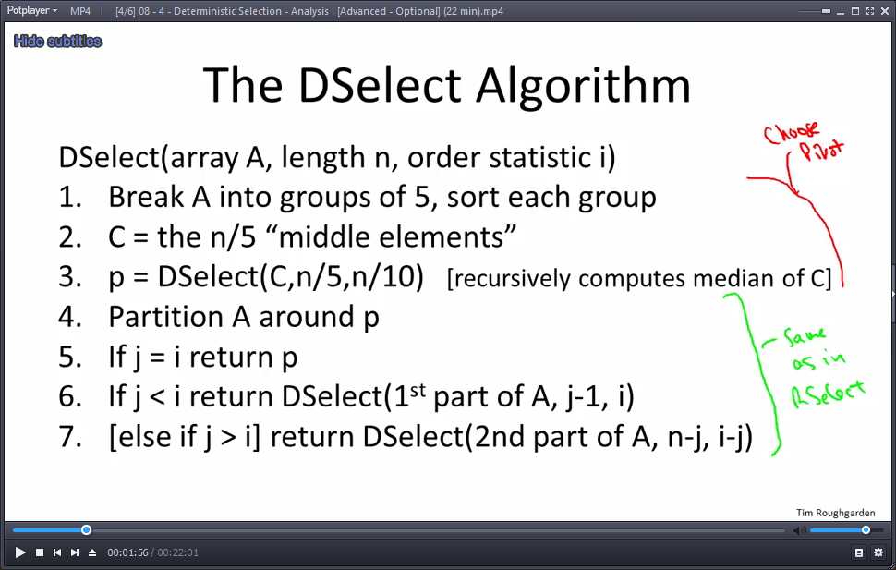

Recursive calls:

* 1 in line 3.
* 1 in 6 (or) 7.

Warning: not as good as RSelect in practice.

* Bigger constants.
* Requires additional memory storage.

## 08 - 4 - Deterministic Selection - Analysis I [Advanced - Optional] (22 min)

Notes:

* There are two different recursive calls.
* Outside of recursive calls, it appears to do a lot of work as well.

**Line (1) Break A into groups of 5**, sort each group.

* Running time:  - this is surprising.

**Isn’t sorting always nlogn?**

* We’re doing something much more modest than sorting the n elements.
* We’re only sorting puny 5 element arrays. (constant time, O(N) of these)
* Sorting 5 elements ≤ 120 operations. (e.g. merge-sort)
  1. 
  2. So: 
  3. Explained again: we’re just cleverly moving a couple elements while running across the array.

Let’s go over the running time of the DSelect Algorithm again:

* Step 1 – break into groups of 5 and sort - 
* Step 2 – copy “middle elements” into C - 
* Step 3 – find pivot via recurse on array of size n/5 - 
* Step 4 – partition around pivot - 
* Step 5 – lucky case … not in running time analysis
* Steps 6+7 - recurse on one of the subarrays –  - depends on quality of pivot!

**Rough recurrence:**

1. 
2. 

**The Key Lemma:** we’ll get a pretty good pivot

* Subarray will be of size  of previous run.
* Upshot: we can replace  with 

**Rough Proof:**

* Let k = n/5 = # of groups
*  = ith smallest of the k middle elements.
* [so pivot =  ]
* There’s at least 30 percent elements smaller than the pivot!
* Goal: ≥ 30% of input array smaller than .

Thought experiment:

* Imagine we lay out elements of A in a 2-D grid.
* Each column has 5 elements.
* Middle row = middle elements.



* We’re going to arrange the columns in increasing order of middle elements.
* Our pivot would be bigger than the bottom left yellow area, thus giving us the 30%.

Example:



**Key point:**  bigger than 3 out of 5 (60%) in roughly 50% of the groups.

* 
* Similarly, smaller than 30% of array.

## 08 - 5 - Deterministic Selection - Analysis II [Advanced - Optional] (13 min)

Does the extra work negate the goodness of finding a “pretty good” pivot?

**Rough recurrence:**

* 
* 

How do we solve this?

* Different-sized subproblems => can’t use Master Method.
* Strategy: “hope and check”
* Hope: there is some constant a [independent of n] such that 

**Analysis of Rough Recurrence:**

* Claim: Let a=10c
* Then: 
* Proof: by induction on n.
  1. Base case: T(1) = 1≤a*1 (since a≥1)
  2. Inductive step: [n>1]
     + Inductive Hypothesis:
     + 
     + 

**Indeed, DSelect runs in O(n) time.**

## 08 - 6 - Omega(n log n) Lower Bound for Comparison-Based Sorting [Advanced - Optional] (13 min)

**A Sorting Lower Bound**

* We cannot do “comparison based” sorting in linear time.
* Comparison-Based Sort: accesses input array elements only via comparisons. (“General-purpose sorting method” without knowing the guts of the items compared).
  1. E.g. Merge Sort (compare by copy), Quick Sort (swap in place), Heap Sort (bubble up comparisons, extract minimum N times)
  2. Non Examples: Bucket Sort, Counting Sort, Radix Sort

1. **Bucket Sort** – good for data from distributions
   1. distributional assumption on the data
   2. e.g. Independent, Identically Distributed (IID) samples from the uniform distribution on [0:1]

Pre-allocate n buckets of width 1/n.

With a single pass O(n), we can classify the input elements to their buckets.

The assumption that data is uniform at random, we expect each bucket to have a small population – one element per bucket.

We can now use Insertion-Sort on each bucket (tiny number of elements means constant time per bucket and linear time per entire data – O(n))

1. **Counting Sort** – good for small integers (e.g. values between 0 and k)
   1. K needs to be at most linear in ‘n’.
   2. Single pass through the input array, bucket the elements according to what their value is. (Somewhere between 0 and k (an integer by assumption). So you need K buckets. And you do a pass, and you depopulate the buckets and copy them to an output array. This runs in O(n+k) – k is the size of the biggest integer.
   3. Upshot: if we’re willing to assume data elements are integers bounded by factor linear in N (proportional to N, then you can sort them in linear time).
2. **Radix Sort** – good for medium-size integers : can be considered as an extension of ‘counting sort’ (although other stable sorts can be used as well).
   1. **Upshot**: assume data input is integers – think of them in digit representation.
   2. **Sort one bit at a time.** (from LSB to MSB)
   3. If integers are not too big (polynomially bounded in N), then it gives O(N).

**Proof Idea (why you can’t do better than nlogn with comparison based sorting):**

* Assume n different values (harder to sort), we get n! (n factorial) possible input orders.
* Suppose algorithm makes ≤ k comparisons.
* Across n! inputs algorithm exhibits  distinct executions (resolutions of comparisons).
* By the Pigeonhole Principle (can’t stuff k+1 pigeons in k holes with surplus)
  1. Pigeons: n! different inputs (arrangements of data elements).
  2. Holes:  different executions of the sorting method.
  3. If  then by pigeonhold principle, one ‘cubby hole’ takes two pigeons.

I.e. two different inputs get treated exactly the same way by the sorting method’s algorithm. The comparisons resolve identically.

If this happens – the algorithm is “toast”. Definitely not correct.

* Thus, 

# 09 - Week 03 - Graphs and the Contraction Algorithm

## 09 - 1 - Graphs and Minimum Cuts (16 min)

**Contraction Algorithm**

* Goals for these lectures:
* Further practice with randomized algorithms (new domain: graphs)
* Introduction to graphs and graph algorithms.

**Graphs:** represent pair-wise relationships amongst a set of objects.

* Two ingredients:
  1. Vertices aka nodes (V)
  2. Edges € = pairs of vertices
     + Can be undirected [unordered pair] or directed [ordered] (aka arcs)

Examples: road networkds, the Web, social networks, precedence constraints (e.g. advanced courses depending on entry level ones), etc.

**Cuts of Graphs:**

* Definition: a cut of a graph (V, E) is a partition of V into two non-empty sets A and B.



* Definition: the crossing edges of a cut (A, B) are those with:
  1. The one endpoint in each of (A,B) [undirected]
  2. Tail in A, head in B [directed] (we mostly ignore the other direction)
* A cut with n vertices has (roughtly)
  1. Each node is either in the cut or out of the cut:
  2.  (slightly incorrect – a cut can’t be empty)

**The Minimum Cut Problem:**

* Input: An undirected graph G=(V, E).

[Parallel edges allowed]

Parallel edges

[See other video for representation of the input]

* Goal: Compute a cut with the **fewest number of crossing edges**. (a min cut)

**What is the min cut value here?**

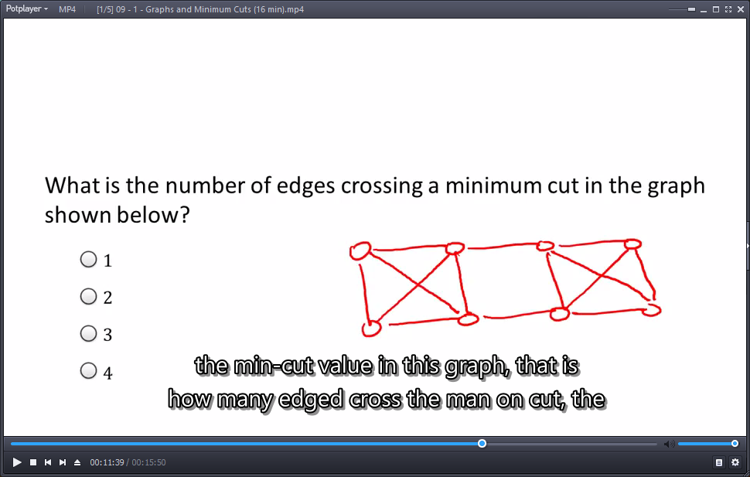

Answer: 2



**A Few Applications:**

* Indentify network bottlenecks /weaknesses
* Community detection in social networks (highly connected group that is weakly connected to the rest of the Social Network Graph).
* Image segmentation
  1. Input = graph of pixels
  2. Use edge weights

[(u,v) has large weight 

“expect” u,v to come from some object – e.g. similar color maps]

* 1. Hope: repeated min cuts identifies the primary objects in picture.

## 09 - 2 - Graph Representations (14 min)

An undirected graph that has  vertices, no parallel edges, and is connected (i.e., “in one piece”). What is the min and max number of edges that the graph cold have?

* Min = (e.g., broken circle/master-slaves) n-1 edges.
* Max = (each connected to all others – next in line has one less connection to make)



**Min:** Think about adding the edges one at a time. Initially, you just have a graph with zero edges: n different pieces and isolated vertices with no edges at all. Each time you add one edge, you fuse two existing pieces and fuse them into one. The maximum decrease in the number of different pieces is 1 each time you add an edge. Starting with n different pieces, getting down to 1 pieces, it is clear why the min is n-1.

**Sparse vs. Dense Graphs:**

* Some data structures and algorithms are better for sparse/dense graphs.
* Let **n** = # of vertices, **m** = # of edges.
* Most applications:  (i.e. connected, no parallel edges)
* Sparse – m closer to linear; dense – m closer to quadratic.

**The Adjacency Matrix**

* Represent G by an  {0,1} matrix A where if  , it means G has an i-j edge.
* Variants:
* 
* 
* 
* **Required space =** 
  1. OK – for dense graphs.
  2. Wasteful – for sparse graphs.

**Adjacency Lists:**

* Ingredients:
  1. Array (or list) of vertices
  2. Array (or list) of edges
  3. Each edges points to its endpoints
  4. Each vertex points to edges incident on it
     + Space:  - one to one correspondence with ‘iii’.
* **Required space =**  [or ]
* This course focuses on adjacency lists.
  1. Adjacency lists are perfect for graph searches.
  2. Many graph motivations come from massive graph networks, which are sparsely connected.
     + Example: Web nodes spans roughly , so a matrix representation would be  (unfeasible) while an adjacency list is .

## 09 - 3 - Random Contraction Algorithm (9 min)

**Random Contraction Algorithm:** [David Karger, early 90s]

(To aid us in finding the **min cut**, the cut with fewest edges crossing between A and B)

* Basic idea: Random Sampling
* While there are more than 2 vertices:
  1. Pick a remaining **edge** (u,v) uniformly at random.
  2. Merge (or “contract”) u and v into a single vertex.
  3. Remove self-loops
  4. Return cut represented by final 2 vertices.

**Example 1: Min Cut**



**Example 2: NOT a min cut!**

## 09 - 4 - Analysis of Contraction Algorithm (30 min)

**Key Question:** What is the probability of success?

* Fix a graph G = (V,E) with n vertices, m edges.
* Fix a minimum cut (A,B) [we don’t care if there are other min cuts]
* Let k = # of edges crossing (A,B). (Call these edges F)

**What could go wrong?**

1. Suppose an edge of **F is contracted** at some point -> Will **not** output (A,B)
2. Suppose only edges inside A or inside B get contracted. Will output (A,B)
3. Thus: 

* Let  = event that an edge of F was contracted in iteration i.
* **Goal:** Compute  (no edge from F is contracted at any step)

**The probability that an edge crossing the min cut (A,B) is chosen in the first iteration:**

* (n – vertices, m – edges, k – crossing edges)



**The First Iteration:**

* Key Observation: degree (# of incident edges) of each vertex is at least k.
* Reason: each vertex v defines a cut ().
* Since 
* Thus:
* 

**The Second Iteration:**

* Recall: 
* Note: all nodes in contreacted graph define cuts in G (at least k crossing edges)
* All degrees in contracted graph are at least k
* So: # of remaining edges 
* 
* 

**All Iterations:**



This gives a **low, but non trivial success rate**. (recall,  cuts!)

**Repeated Trials:** how many trials needed?

* Let  = event that the cut (A,B) is found on the i-th try.
* (by definition, different  ‘s are *independent*)
* So:



* From Calculus: 
* So:
* If we take 
* If we take  - small chance for failure!
* Running time: polynomial in n and m but slow - 
  1. But we can do better with more ideas. (roughly )
  2. Expecially, not just repeated “dummy” trials.

## 09 - 5 - Counting Minimum Cuts (7 min)

**The Number of Minimum Cuts:**

* Note: A graph can have multiple min cuts.

[e.g., a star graph with n vertices has (n-1) minumum cuts]

* Quesiton: What’s the largets number of min cuts that a graph with n vertices can have?
* Answer:



**The Lower Bound:**

* Consider the n-cycle.
* Note: each (adjacent) pair of the n edges defines a distinct minimum cut (with two crossing edges).

(n = 8)

* Has:

 min cuts

**The Upper Bound:**

* Let  be the min cuts of a graph with n vertices.
* By the Contraction Algorithm analysis (without repeated trials):



* Note: ’s are disjoint events (i.e., only one can happen)
* Their probabilities sum to at most 1
* Thus:



## Problem Set-3

### Question 1

How many different minimum cuts are there in a tree with *n* nodes (ie. *n*−1 edges) ?





*n*

*n*−1

**Ex:**

1 node – 1 cut

2 nodes – 1 cut

3 nodes – 2 cuts (one cut has 2 edges)

4 nodes – 3 cuts

5 nodes – 4 cuts

Etc.

### Question 2

Let "output" denote the cut output by Karger's min cut algorithm on a given connected graph with *n* vertices, and let *.* Which of the following statements are true? For hints on this question, you might want to watch the short optional video on "Counting Minimum Cuts".

For every graph *G* with *n* nodes, there exists a min cut (*A*,*B*) of *G* such that *Pr*[*out*=(*A*,*B*)]≥*p*.

For every graph *G* with *n* nodes and every min cut (*A*,*B*) of *G*, *Pr*[*out*=(*A*,*B*)]≥*p*.

For every graph *G* with *n* nodes and every min cut (*A*,*B*), *Pr*[*out*=(*A*,*B*)]≤*p*.

For every graph *G* with *n* nodes, there exists a min cut (*A*,*B*) such that *Pr*[*out*=(*A*,*B*)]≤*p*.

There exists a graph *G* with *n* nodes and a min cut (*A*,*B*) of *G* such that *Pr*[*out*=(*A*,*B*)]≤*p*.

**Ex:**

1. Yes – see ‘All Iterations’- chance that edges in F will not be contracted ≥ 2/n(n-1)
2. Same as ‘1’
3. The opposite of what we proved (see ‘all iterations’)
4. Same as ‘3’
5. If 

### Question 3

Let  be some constant. Suppose you are looking for the median element in an array using RANDOMIZED SELECT (as explained in lectures). What is the probability that **after the first iteration** the size of the subarray in which the element you are looking for lies is  times the size of the original array?



1−*α*

*α*−1/2

2\**α* - 1

**Ex:**

We randomly (aka uniformly) choose a pivot – location between index 0 and 1 times n.

1. Pivot is smaller than median – from 0 to  (not good) – e.g.  , then Pivot is good if it is larger than 0.3 – chances for that are



**OR…**

1. Pivot is larger than median – from  to 1 (not good) – e.g.  , then Pivot is good if it is smaller than 0.7 –chances for that are



1. Combine the areas (both equally likely – 0.5) we get the result.
   1. 

### Question 4

Let  be a constant, independent of *n*. Consider an execution of RSelect in which you always manage to throw out at least a 1−*α* fraction of the remaining elements before you recurse. What is the maximum number of recursive calls you'll make before terminating?









**Ex:**

If we always throw out the fraction  , that means that on iteration j, we have (worst case):  the max number of recursive calls required:



### Question 5

The minimum s-t cut problem is the following. The input is an undirected graph, and two **distinct vertices** of the graph are labelled "**s**" and "**t**". The goal is to compute the minimum cut (i.e., fewest number of crossing edges) that satisfies the property that s and t are on different sides of the cut.

Suppose someone gives you a subroutine for this s-t minimum cut problem via an API. Your job is to solve the original minimum cut problem (the one discussed in the lectures), when all you can do is invoke the given min s-t cut subroutine. (That is, the goal is to **reduce the min cut problem to the min s-t cut problem**.)

Now suppose you are given an instance of the minimum cut problem -- that is, you are given an undirected graph (with no specially labelled vertices) and need to compute the minimum cut. What is the minimum number of times that you need to call the given min s-t cut subroutine to guarantee that you'll find a min cut of the given graph?



*n*−1



*n*

**Ex:**

Our API can find min cut where two given vertices are at opposing cuts. To guarantee that with this API we can find a real min cut (for all vertices), we must run it…

* 2 nodes – 1 run
* 3 nodes – 1 run
* 5 nodes…. Drawing suggests that once we pick one, we have to pick the other from the opposite group. Worst case – 1 alone and the opposite group is all the others – thus, we have to pick that exact single node that gives the correct answer.
  1. N-1 options.

## Programming Question – 3

<https://class.coursera.org/algo-009/quiz/index?quiz_type=homework>

### Question 1

Download the text file [here](http://spark-public.s3.amazonaws.com/algo1/programming_prob/kargerMinCut.txt). (Right click and save link as)

The file contains the adjacency list representation of a simple undirected graph. There are **200 vertices** labeled 1 to 200. The **first column** in the file represents the **vertex label**, and the particular **row** (other entries except the first column) tells all the vertices that the vertex is adjacent to. So for example, the 6*th* row looks like : "6 155 56 52 120 ......". This just means that the **vertex with label 6 is adjacent to** (i.e., shares an edge with) the vertices with labels 155,56,52,120,......,etc  
  
Your task is to code up and run the **randomized contraction algorithm for the min cut problem** and use it on the above graph to compute the min cut (i.e., the minimum-possible number of crossing edges).

(HINT: Note that you'll have to **figure out an implementation of edge contractions**. Initially, you might want to do this naively, creating a new graph from the old every time there's an edge contraction. But you should also think about more efficient implementations.)

(WARNING: As per the video lectures, please make sure to run the algorithm many times with different random seeds, and remember the smallest cut that you ever find.)

**Answer:**

**17**

**See:** [**https://github.com/OferSheffer/Review_Stanford_Algorithms/tree/master/src/P01W03Q01**](https://github.com/OferSheffer/Review_Stanford_Algorithms/tree/master/src/P01W03Q01)

# 10 - Week 04 - Graph Search and Connectivity

## 10 - 1 - Graph Search - Overview (23 min)

**A few motivations:**

* Check if a network is connected (travel between every pair of nodes)
* Plan formulation, driving directions
* Compute the “pieces” (or “components”) of a graph, -- clustering, structure of the Web graph, etc.
* **NOTE:** try to think of a path more abstractly, instead of ‘roads’, as a sequence of decisions taking some initial state. (e.g. solving a Sudoku puzzle)
  1. Node = a partially completed puzzle.

**Generic Graph Search:**

* Goals:  time
  1. Find everything findable from a start index
  2. Don’t explore anything twice
* Generic Algorithm: (given graph G, vertex s)
  1. Initially: s explored, others not-explored.
  2. While possible: (if none, halt)
     + Choose an edge (u, v) with u explored and v unexplored.
     + Mark v explored.
* Claim: at the end of the algorithm, v explored ⬄ G has a path from s to v.

(G undirected or directed)

* Proof: (=>) induction on number of iterations ( you check )
* (<=) By contradiction. Suppose G has a path P from s to v:



* But v unexplored at end of the algorithm. Then there exists an edge (u,x) in P with u explored and x unexplored.
* But then algorithm would not have terminated, contradition.

**BFS vs. DFS:**

How do we choose from the “frontier” edges?

Breadth-First Searh (BFS): O(m+n) time using a queue (FIFO)

* Explored nodes in “layers”
* Can compute shortest paths
* Cano computed connected components of an undirected graph

Depth-First Searh (DFS): O(m+n) time using a stack (LIFO) – (or via recursion)

* Explore aggressibly like a maze, backtrack only when necessary
* Compute topological ordering of a directed acyclic graph
* Compute connected components in directed graphs.

## 10 - 2 - Breadth-First Search (BFS)_ The Basics (14 min)

**Overview and Example:**

* Explore nodes in “layers”
* Overview – see above.

**The Code – BFS**

BFS (graph G, start vertex s)

[ all nodes initialy unexplored ]

* Mark s as explored [ keep a boolean to mark each note as explored/not ]
* Let Q = queue data straucture (FIFO), initialized with s
* 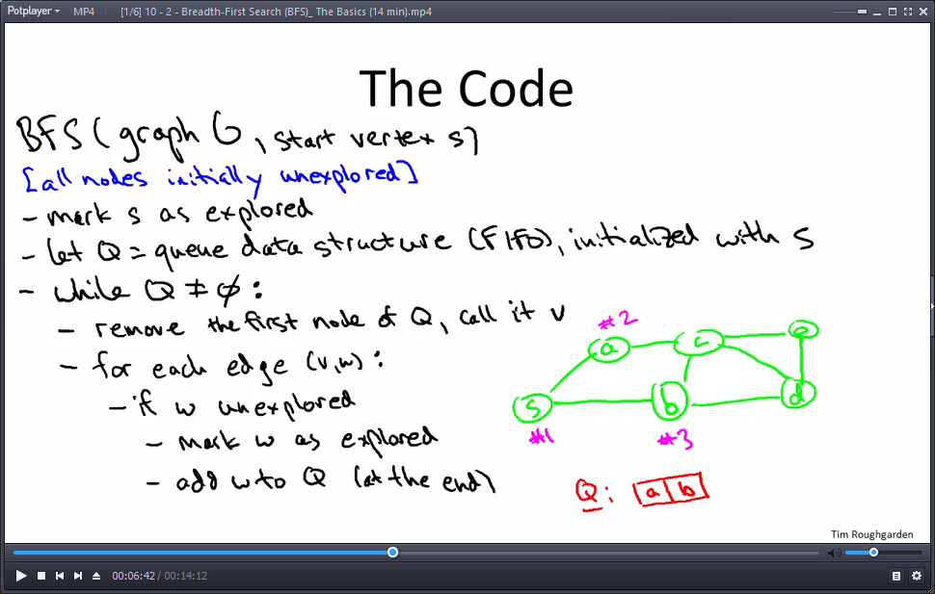While  :
  + Remove the first node of Q, call it v
  + For each edge (v, w):
    - If w unexplored
      * Mark w as explored
      * Add w to Q (at the end)

**Notes:**

* ‘If w unexplored’ + ‘mark and add w’ – O(1)
* A **queue**: add to back in O(1), pick from front in O(1).
  + Possible implementation with a doubly linked list.
  + Python – from collections import deque (add/remove on both ends O(1))

**Basic BFS Properties:**

* Claim 1: at the end of BFS, v explored ⬄ G has a path from s to v
* Reason: special case of the generic algorithm
* Claim 2: running time of main while loop = 
  + where  = # of nodes reachable from s,  = # of edges reachable from s.
* Reason: by inspection of code.
  + Each **node** is inserted into the queue and deleted from it.
    - (one time dealings = constant time)
  + Each **edge** might get looked at twice (from every direction), still constant work.
  + Overall time = O(n+m)

## 10 - 3 - BFS and Shortest Paths (8 min)

**Application: Shortest Paths**

* Goal: compute dist(v), the fewest # of edges on path from x to v.
* Extra code:
  + intialize dist(v) = (0 if v = s, else inf)
  + When considering edge (v, w):
    - If w unexplored, set dist(w) = dist(**V**) + 1.
* Claim: at termination dist(v) = i ⬄ v in ith layer
* (i.e., shortest s-v path has i edges)
* Proof Idea: every layer i node w is added to Q by a layer (i-1) node v via the edge (v, w).

## 10 - 4 - BFS and Undirected Connectivity (13 min)

**Application: Undirected Connectivity**

* Let G=(V,E) – an undirected graph.
* Connected components = “pieces” of G.
* Formal Definition: equivalence classes of the relation u<->v ⬄ there exists u-v path in G. ( )
* [  : equivalence relation (reflexive, symmetric, transitive)]
  + Reflexive: any node is connected to itself.
  + If  , then  (undirectd -> good)
  + Transitive: if 
  + **Note:** maximum mutually related stuff.

* Goal: compute all connected componenets.
* Why? Check if network is disconnected.

**Connected Components via BFS:**

* **Code:** To compute all components: (undirected case)
  + Initialize all nodes as unexplored – O(n)

[assume labelled 1 to n]

* + For i=1 to n: –
    - If i not yet explored (O(n)) [in previous BFS]
      * BFS(G,i)

[discover i’s connected component]

* Note: finds every connected component.
* Running time: O(m+n) – [ O(1) per node, O(1) per edge in each BFS ]

## 10 - 5 - Depth-First Search (DFS)_ The Basics (7 min)

**Overview and Example:**

* Depth First Search (DFS):
* Explore aggressively, only backtrack when necessary.
* Also computes a topological ordering of a directed acyclic graph
* And strongly connected components of directed graphs
* Run Time: 

**The Code – DFS:**

* Exercise (modify BFS):
* mimic BFS code, use a stack instead of a queue [ + some other minor modifications ]
* Recursive (“elegant”) version:
* DFS(graph G, start vertex s)
  + Mark s as explored [ use a boolean flag ]
  + For every edge (s,v):
    - If v unexpored:
      * DFS(G,v)

**Basic DFS Properties:**

* Claim 1: at the end of a the algorithm, v marked as expored ⬄ there exists a path from s to v in G.
* Reason: particular instrantiation of generic search procedure
* Claim 2: running time is  - n,m sub s – reachable nodes/edges from s.
* Reason: looks at each node in the connected component of s at most once, each edge at most twice.

## 10 - 6 - Topological Sort (22 min)

**Application: Topological Sort:**

* Definition: a topological ordering of a directed graph G is labeling ‘f’ of G’s nodes such that:
  + The f(v)’s are the set {1,2,…,n}
  +  - value of tail is higher than value of head.
* Motivation: sequence tasks while respecting all precedence constraints.
* **Note:** G has **directed cycle => no topological ordering**
* **Theorem:** **no directed cycle => can compute topological ordering in O(m+n) time**.

Example:

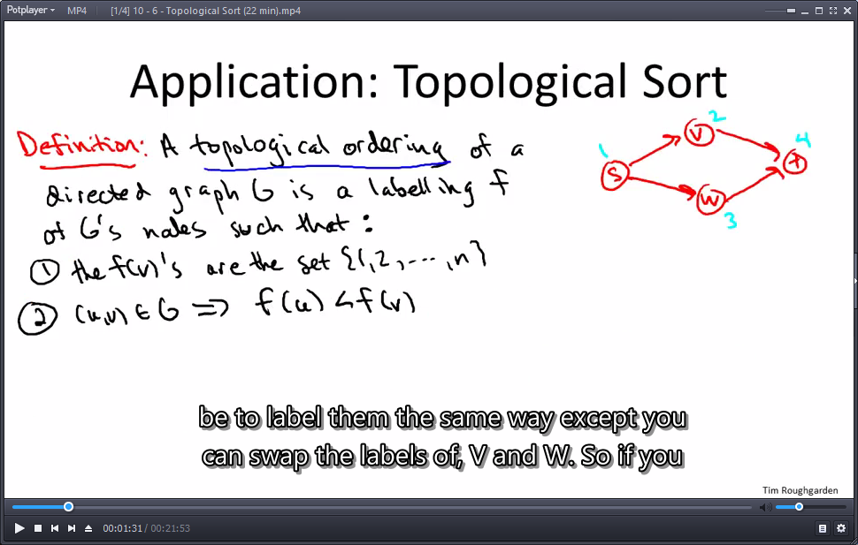 => 

We can also switch labels between v and w (blue vs. green).

**Note:** these are the only legit topological orderings (feel free to check).

We will reduce topological ordering to DFS. But first….

**Straightforward Solution:**

* Note: every **directed acyclic** graph has a sink vertex (without outgoing arcs).
* Reason: if not, can keep following outgoing arcs to produce a directed cycle.
* **Thoughts:** if a node has outgoing arcs, it cannot be the final node in the topology. Only a sink can be the final node. Luckily, if it is directed acyclic, we know there is a sink vertex.
* To compute topological ordering:
  + Let v be a sink vertex of G
  + Set f(v)=n
  + Recurse on G-{v}
* Why does it work? When v is assigned to position i, all outgoing arcs already deleted => all lead to later vertices in ordering.
* **Example:** we pick the only sink ‘4’, then we have 2 “sink” options (once arcs to ‘4’ have been deleted). I.e. 2 possible topological orderings.

**Topological Sort via DFS (Slick):**

DFS**-**Loop**(**graph G**):**

mark all nodes unexplored

current**-**label **=** n ***// to keep track of ordering***

**for** each vertex**:**

**if** v not yet explored**:** ***// in previous DFS call***

DFS**(**G**,** v**)**

DFS**(**graph G**,** start vertex s**):**

 **for** every edge **(**s**,** v**):**

**if** v not yet explored**:**

mark v explored

DFS**(**G**,** V**)**

set f**(**s**)** **=** current_label

current_label **=** current_label**-**1

**Key Properties:**

* Running Time: 
* Reason: O(1) time per node, O(1) time per edge.
* Correctness: need to show that if (u,v) is an edge, then f(u) < f(v)

- [no directed cycles]

* Case 1:
* u visited by DFS before v => recursive call corresponding to v finishes before that of u (since DFS). => f(v) > f(u)
* Case 2:
* v visited before u => v’s recursive call finishes before u’s starts. => f(v) > f(u)

## 10 - 7 - Computing Strong Components_ The Algorithm (29 min)

**Consider the 4 node graph:**



There are paths from one side to the other, but it is **not** considered “strongly connected”. You can get from every point to every other point.

**Strongly Connected Components:**

* Formal Definition: the strongly connected components (SCCs) of a directed graph G are the equivalence classes of the relation:
*  .
* You check:  is an equivalence relation (see: 10-4).



Any two pairs of nodes which lie in two different circles, you either won’t have a path from the first to the second or you won’t have a path from the second to the first.

**Notice:** the structure of the strong components in this graph exactly mirrors the directed acyclic graph in red above.

**Why Depth First Search?**

* DFS is fast, which allow SCC to be fast endough to be considered **‘key primitives’**, i.e. it doesn’t cost much to use for helping other algorithms.
* Thinking on DFS:
* Let’s say we pick a node in the rightmost SCC – DFS will reveal only the nodes in the rightmost SCC (you can’t escape it – other arcs point towards SCC, not outwards).
* i.e. any node from the rightmost SCC will discover that SCC.

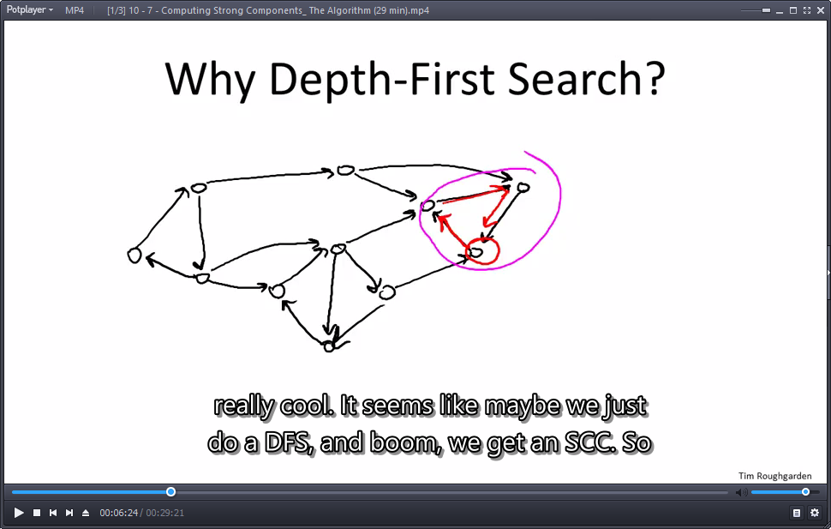

* However, if we don’t pick a node from that SCC, we get extra nodes. We get a union of multiple SCCs.
* Takeaway: calling DFS from the right place, you uncover an SCC. (“magical ordering”)

**Kosaraju’s Two Pass Algorithm:**

* Theorem: can compute SCCs in O(m+n) time.
* Algorithm: (given directed graph G)
  + Let Grev = G with all arcs reversed

[naively: Grev=new graph, smart: go backwards on original edges]

* + Run DFS-Loop on Grev -- [Goal: compute “magical ordering” of nodes]

Let **f(v) = “finishing time”** of each v in V

* + Run DFS-Loop on G -- [Goal: discovr the SCCs one-by-one]

Processing nodes in **decreasing oder of finishing times**

[SCCs = nodes with the same “leader”]

**DFS-Loop:**

DFS**-**Loop**(**graph G**):**

"""updated DFS for SCC"""

global variable t **=** 0 ***// for finishing times in 1st pass***

***// # of nodes processed so far***

global variable s **=** Null ***// for leaders in 2nd pass***

***// current source vertex***

***// Assume nodes labelled 1 to n***

**for** i **=** n down to 1**:**

**if** i not yet explored**:**

s **=** i

DFS**(**G**,** i**)**

DFS**(**graph G**,** node i**):**

mark i as explored ***// for rest of calling DFS-Loop function***

set leader**(**i**)** **=** node s

**for** every arc **(**i**,** j**)** in G**:**

**if** j not yet explored**:**

DFS**(**G**,** j**)**

t**++**

set f**(**i**)** **=** t ***// i's finishing time***

**Example:**

Figure 5(a) displays a reversed graph Grev, with its vertices numbered arbitrarily, and the f-values computed in the first call to DFS-Loop. In more detail, the first DFS is initiated at node 9. The search must proceed next to node 6. DFS then has to make a choice between two different adjacent nodes; we have shown the f-values that ensue when DFS visits node 3 before node 8.2 When DFS visits node 3 it gets stuck; at this point node 3 is assigned a finishing time of 1. DFS backtracks to node 6, proceeds to node 8, then node 2, and then node 5. DFS then backtracks all the way back to node 9, resulting in nodes 5, 2, 8, 6, and 9 receiving the finishing times 2, 3, 4, 5, and 6, respectively. Execution returns to DFS-Loop, and the next (and final) call to DFS begins at node 7. Figure 5(b) shows the original graph (with all arcs now unreversed), with nodes labeled with their finishing times. The magic of the algorithm is now evident, as the SCCs of G present themselves to us in order: the first call to DFS discovers the nodes 7–9 (with leader 9); the second the nodes 1, 5, and 6 (with leader 6); and the third the remaining three nodes (with leader 4).





**Running time:** 

**Note:** in the second pass we need to process the nodes in decreasing order of finishing time. **Sorting – nlog: bad!**, must remember in the first pass the order in which the nodes completed so the second pass will require only a linear scan.

## 10 - 8 - Computing Strong Components_ The Analysis (26 min)

**Observation:**

Summarizing, every directed graph has a useful “two-tier” structure: zooming out, one sees a Directed Acyclic Graph (DAG) on the SCCs of the graph; zooming in on a particular SCC exposes its finer-grained structure.

* Meta-nodes: the SCCs - 
* 

Why acyclic? A cycle of SCCs would collapse into one.



Graph and its Meta-Graph

When reversing the arcs, SCCs of G remain SCCs in Grev.

**Key Lemma:** See 10 – 7 – scc pdf

* Adjacent SCCs, C1 and C2 with arc (i,j)
* 
* Corollary: maximum f-value of G must lie in a “sink SCC”.

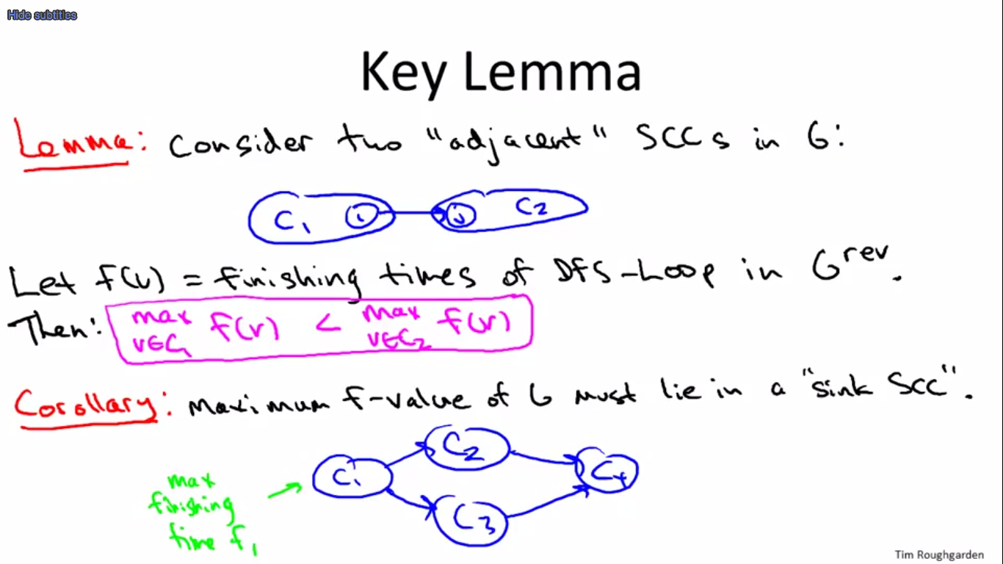

 (C4 good first choice for 2nd pass DFS)

**Proof of Key Lemma:**









**Correctness Intuition:**

By corollary: 2nd pass of DFS-Loop begins somewhere in a sink SCC and successive calls to DFS “peel off” the SCCs one by one. [in reverse topological order of the “meta-graph” of SCCs]

## 10 - 9 - Structure of the Web [Optional] (19 min)



**The Bow Tie:**



**Main Findings:**

1. All 4 parts (giant, IN, OUT, tubes + tendrils) have roughly the same size (roughly 25%)
2. Within CORE, very well connected (has the “small world” property) [Milgram]
   1. “small world” – also called ‘six degrees of separation’.
   2. A web-based “small world” includes cues on how to get from one point to another quickly. I.e. routing information is easy in “small world” networks.
3. Outside, surprisingly poorly connected.

**Modern Web Research:**

1. Temporal aspects – how is the web graph evolving over time?
2. Informational aspects – how does new information propagate throughout the Web (or blogosphere, or Twitter, etc.)
3. Finer-grained structure – how to define and compute “communities” in information and social networks? One motivation of ‘cuts’ is to identify communities that are relatively densely connected inside (and sparsely connected outside).

**Recommended Reading:** Easley + Kleinberg, “Networks, Crowds, & Markets”

## Problem Set-4

### Question 1

Given an adjacency-list representation of a **directed** graph, where each vertex maintains an array of its outgoing edges (but *not* its incoming edges), how long does it take, in the worst case, to compute the in-degree of a given vertex? As usual, we use *n* and *m* to denote the number of vertices and edges, respectively, of the given graph. Also, let *k* denote the maximum in-degree of a vertex. (Recall that the in-degree of a vertex is the number of edges that enter it.)

Cannot determine from the given information

*θ*(*m*)

*θ*(*k*)

*θ*(*n*)

**Ex:**

We have no input on how many arcs the graph holds, maybe more, maybe less than nodes. i.e. the adjacency list would hold a node number, but no outgoing edges.

**Had there been a minimum of one arc per node**, then the process is dominated by O(m) via: for node in Graph -> for arc in node -> Count[arc[1]]++; if Count==k break.

### Question 2

Consider the following problem: given an **undirected** graph *G* with *n* vertices and *m* edges, and two vertices *s* and *t*, does there exist at least one *s*-*t* path?   
If *G* is given in its adjacency list representation, then the above problem can be solved in *O*(*m*+*n*) time, using BFS or DFS. (Make sure you see why this is true.)   
Suppose instead that *G* is given in its adjacency **\*matrix\*** representation. What running time is required, in the worst case, to solve the computational problem stated above? (Assume that *G* has no parallel edges.)



*θ*(*n*∗*m*)

*θ*(*m*+*n*)

*θ*(*m*+*n*log*n*)

**Ex:**

In a matrix, each node has n options with connected/not. In the worst case, for each node it takes O(n) to find who’s the next link that will lead to ‘t’. We have to do this for each node. I.e. O(n) times. As a result, running time is O(n^2).

### Question 3

This problem explores the relationship between two definitions about graph distances. In this problem, we consider only graphs that are undirected and connected. The ***diameter*** of a graph is the maximum, over all choices of vertices *s* and *t*, of the shortest-path distance between *s* and *t*. (Recall the shortest-path distance between *s* and *t* is the fewest number of edges in an *s*-*t* path.)   
Next, for a vertex *s*, let ***l*(*s*)** denote the maximum, over all vertices *t*, of the shortest-path distance between *s* and *t*. The ***radius*** of a graph is the minimum of *l*(*s*) over all choices of the vertex *s*.   
Which of the following inequalities always hold (i.e., in every undirected connected graph) for the radius *r* and the diameter *d*? [Select all that apply.]

*r*≤*d*

*r*≤*d*/2

*r*≥*d*/2

*r*≥*d*

**Ex:**

Example – 4 nodes. Connected like a chain. Diameter=max(spd(s,t))=max(possible spds)=3 (longest path in the chain). L(s)=max(spd(s,t))=max(possible spds between given s and not given t)->L(1)=L(4)=3 (same as diameter), L(2)=L(3)=2 (connecting a middle node with it’s max spd on the corner. Radius=min(L(s))=2. So, d is bigger than r. Also: r is bigger than d/2.

Next – fully connected graph. D=1. L(s)=1 (for every s), thus R=1. Same as before.

Next – long chain – 10 nodes. D=9. R=Lmin (occurs on a middle node)=5. Thus, R must be bigger than half of D.

### Question 4

Consider our algorithm for computing a topological ordering that is based on depth-first search (i.e., NOT the "straightforward solution"). Suppose we run this algorithm on a graph *G* that is NOT directed acyclic. Obviously it won't compute a topological order (since none exist). Does it compute an ordering that minimizes the number of edges that go backward? For example, consider the four-node graph with the six directed edges (*s*,*v*),(*s*,*w*),(*v*,*w*),(*v*,*t*),(*w*,*t*),(*t*,*s*). Suppose the vertices are ordered *s*,*v*,*w*,*t*. Then there is one backwards arc, the (*t*,*s*) arc. No ordering of the vertices has zero backwards arcs, and some have more than one.

If and only if the graph is a directed cycle

Sometimes yes, sometimes no

Always

Never

**Ex:**

In given example, starting at V->t->s->W gives the minimum (s,v)

If W is chosen as lead W->t->s->V, we get (s,w) and (v,w)

i.e. sometimes yes, sometimes no.

A directed cycle is always ‘yes’, but that doesn’t change our answer.

### Question 5

On adding one extra edge to a directed graph *G*, the number of strongly connected components...?

...could remain the same (for some graphs *G*)

...never decreases by more than 1 (no matter what *G* is)

...never decreases (no matter what *G* is)

...will definitely not change (no matter what *G* is)

**Ex:**

Strongly connected is not the same as a complete graph. I.e. an edge could directly connect two nodes that have a path between them. The number of SCCs would remain the same.

Could it decrease by more than 1? Assume meta-graph with three nodes. Two of them connected with directed arcs in a chain. Closing the chain into a cycle will reduce the meta-graph from 3 to 1 SCC.

## Programming Question-4

### Question 1

Download the text file [here](http://spark-public.s3.amazonaws.com/algo1/programming_prob/SCC.txt). Zipped version [here](http://spark-public.s3.amazonaws.com/algo1/programming_prob/SCC.zip). (Right click and save link as)

The file contains the edges of a directed graph. Vertices are labeled as positive integers from 1 to 875714. Every row indicates an edge, the vertex label in first column is the tail and the vertex label in second column is the head (recall the graph is directed, and the edges are directed from the first column vertex to the second column vertex). So for example, the 11*th* row looks liks : "2 47646". This just means that the vertex with label 2 has an outgoing edge to the vertex with label 47646  
  
Your task is to code up the algorithm from the video lectures for computing strongly connected components (SCCs), and to run this algorithm on the given graph.   
  
Output Format: You should output the sizes of the 5 largest SCCs in the given graph, in decreasing order of sizes, separated by commas (avoid any spaces). So if your algorithm computes the sizes of the five largest SCCs to be 500, 400, 300, 200 and 100, then your answer should be "500,400,300,200,100". If your algorithm finds less than 5 SCCs, then write 0 for the remaining terms. Thus, if your algorithm computes only 3 SCCs whose sizes are 400, 300, and 100, then your answer should be "400,300,100,0,0".  
  
WARNING: Because of the size of the graph you may have to manage memory carefully.

**Answer:**

434821,968,459,313,211

<https://github.com/OferSheffer/Review_Stanford_Algorithms/tree/master/src/P01W04Q01>

# 11 - Week 05 - Dijkstra's Shortest-Path Algorithm

## 11 - 1 - Dijkstra_'s Shortest-Path Algorithm (21 min)

**Single-Source Shortest Paths:**

* Input: directed graph G=(V, E). (m=|E|, n=|V|)
  + Each edge has non negative length 
  + Source vertex s
* Output: for each  , compute
  +  length of a shortest s-v path in G
* Assumption:
  + [for convenience] 
    - Unconnected nodes have path length= infinity

Can be done with preprocessing with BFS

Then we delete the irrelevant part of the graph.

* + - Alternatively, Dijkstra will figure it out on its own.
  + [important]  No negative edges!
    - Bellman-Ford can solve for negative edges.

**Example:**

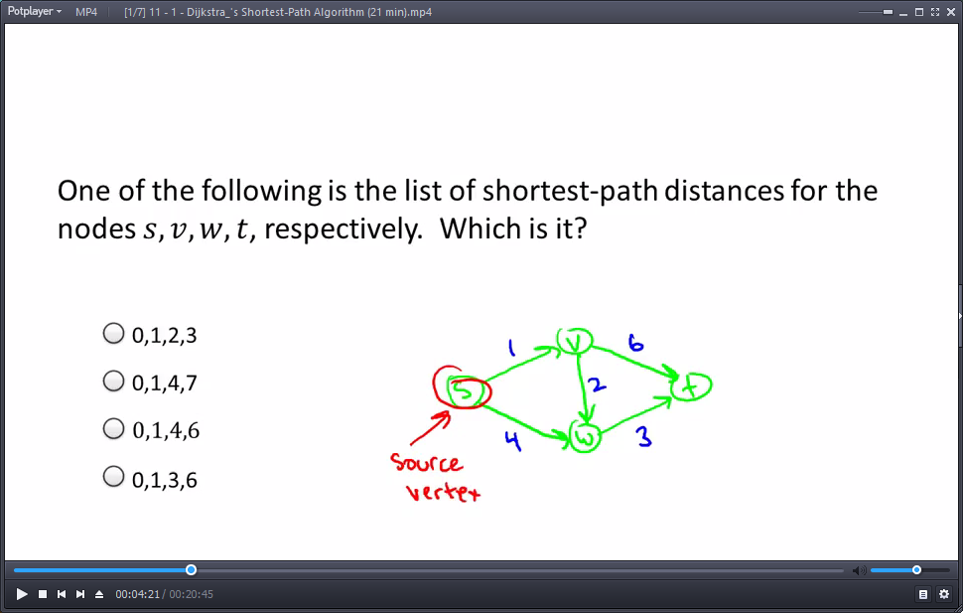

Shortest path for *s, v, w, t* is: 0, 1, 3, 6

* L(s)=0, L(v)=1,
* L(w)=min(4, L(v)+2)=min(4,3)=3,
* L(t)=min(L(v)+6, L(w)+3)=min(7,6)=6

**Why another Shortest Path Algorithm?**

* BFS computes shortest paths in linear time. Albeit, only for  for every edge.
* Why not replace each edge with ones and run BFS?
  + Blows up graph too much.

**Dijkstra’s Algorithm (shortest path):**

"""Initialize"""

X **=** **[**s**]** ***# vertices processed so far***

A**[**s**]** **=** 0 ***# computed shortest path distances***

B**[**s**]** **=** empty path ***# computed shortest paths (only to help explanation)***

"""Main Loop"""

**while** X **!=** V**:**

among all edges **(**v**,** w**)** **in** E **with** v **in** X **and** w **not** **in** X**,**

pick the one that minimizes**:**

A**[**v**]+**l_vw ***# A[v] already computed in earlier iteration***

***# call it (v*, w*)***

add w**\*** to X

set A**[**w**\*]** **=** A**[**v**\*]** **+** l_v**\***w**\***

set B**[**w**\*]** **=** V**[**v**\*]** U **(**v**\*,** w**\*)** ***# new path includes old one and new edge***

Notes:

* We augment X by one new vertex with every iteration.
* No negative lengths -> no way we can return to s with non-positive length
* Direcdtional Graph – cross from X to V-X

[we end up only caring about the ones going from left to right.]

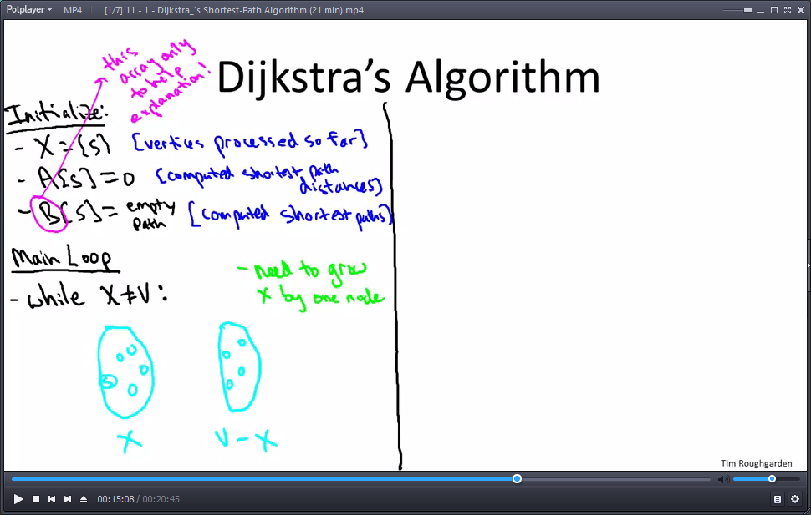

*  is called “Dijkstra’s greedy criterion”

## 11 - 2 - Dijkstra_'s Algorithm_ Examples (13 min)

**Example:**

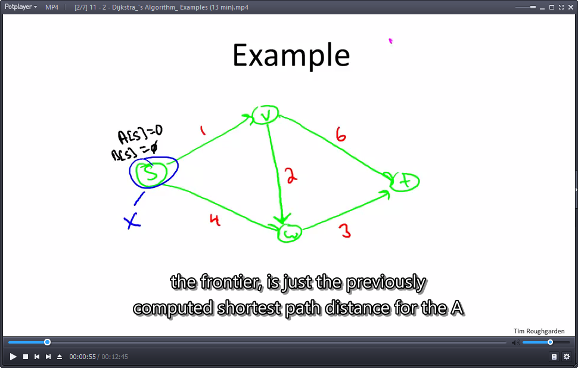

Between L(v)=1, and L(w)=4, so we include v into X:

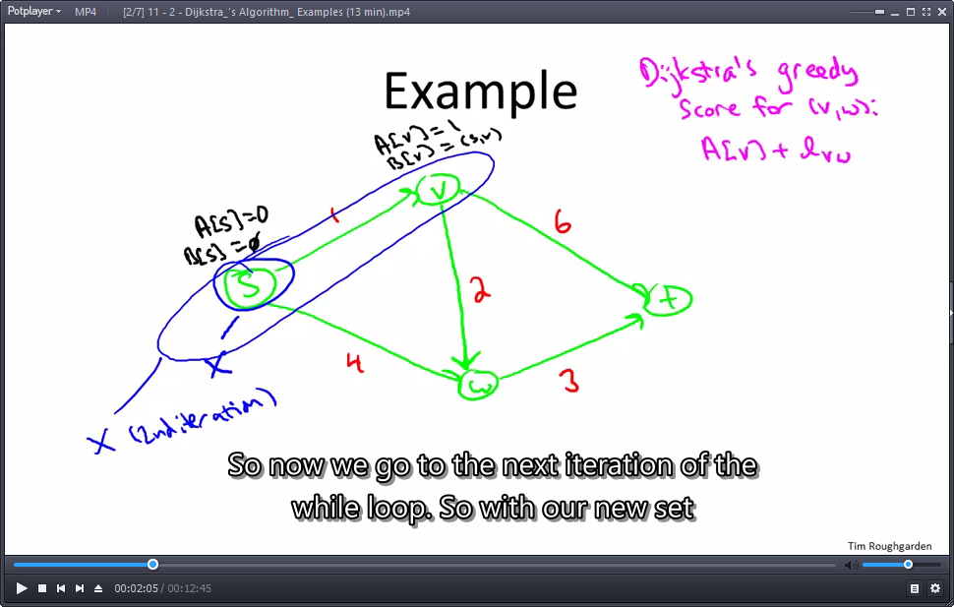

Now, between sw, vw and vt -> min(A[s]+l_sw, A[v]+l_vw, A[v]+l_vt) = min(0+4,1+2,1+6) = 3

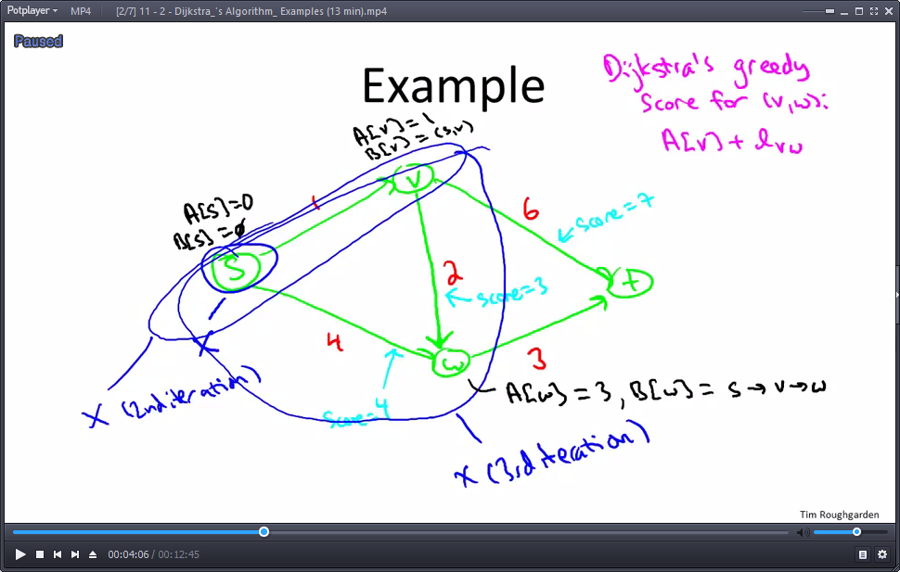

Etc. etc. next up, we compare vt and wt. Get A[t]=6, then we append the min edge to the path.

**Non-Example (Dijkstra’s Shortest Path) – Negative Lengths:**

* **Reduction:** from negatives to non-negative
* Question: why not increase all lengths to eliminate negative edges?
* Answer: doesn’t preserve shortest paths.

e.g. example: adding 5 to every edge ruings the shortest path.

Also: Dijkstra’s Algorithm fails (includes ‘t’ into X on 1st iteration).

## 11 - 3 - Correctness of Dijkstra_'s Algorithm [Advanced - Optional] (19 min)

Correct for any connected, directed graph where all edges are non-negative.

* Assume a path exists.
* Non-negative edges.

Key idea: which vertex we bring into X. Scan frontier and add the one with the smallest distance value. Call it (v*, w*), add w* into X.

**Theorem:**



Proof: by induction on the number of iterations.

* Base case: A[s]=L[s]=0 correct
* Inductive step:
  + Inductive Hypothesis:
  + All previous iterations correct (A[v]=L[v] and B[v] shortest s-v path in G for all v already in X.
  + In current iteration:
  + Pick an edge (v*,w*)

[v* in X, w* not in X]. Add w* to X.

* + Set B[w*]=B[v*] U (v*, w*)
  + Left side length = L(v*) + l_v*w*

B[v*] has length L(v*)

* + Also: A[w*]=A[v*]+l_v*w*=L(v*)+l_v*w*
* Upshot: in current iteration, we set:
  + A[w*]=L(v*)+l_v*w*
  + B[w*]=an s->w* path with length = L(v*)+l_v*w*
* To Finish the proof:

Show that every s-w* path has length ≥ L(v*)+l_v*w* (so our path is shortest)

* So: Let P= any s->w* path. Must “cross the frontier”,
* and so it has the form:



**Total length of path P:** at least A[y]+C_yz

* by Dijkstara’s greedy criterion 

## 11 - 4 - Dijkstra_'s Algorithm_ Implementation and Running Time (26 min)

**Single Source Shortest Paths – Running Time:**



A naïve implementation of this pseudocode:

* One perspective:

(n-1) iterations of while loop,

* + Keep boolean for “in X or not”
  + O(m) work per iteration, O(1) per edge.
* Another view:

For every vertext processed so far, run over all the edges that cross the cut and calculate the min value. Verteces are of order O(n), Edges are of order O(m) => O(mn)

Can we do better? You betcha! Why would we calculate all the cross-border values again and again? Most of them remain the same when the cut X engulfs an extra node.

**Heap Operations (helps get min values faster – log rather than linear):**

* Recall: heap = Insert, Extract-Min in  time.
  + Conceptually, a perfectly balanced binary tree
  + Heap property: every node’s key ≤ children’s keys

Height ~ log2(n)

* + Extract-min: pop root, swapping in last leaf+bubble down.
  + Insert: at the end and bubbling up.
* Also: will need ability to delete from middle of heap. [bubble up or down as needed]

**Two Invariants:**

* Invariant 1: elements in heap = vertices of V-X.
* Invariant 2: for 

Key[v] = smallest Dijkstra greedy score of an edge (u,v) in E with v in X [ if no such edges exist]

Two rounds: 1) local best (e.g. 7 vs 3), heap remembers best results. Take min from the heap (best from locals).

* Point: by invariants, Extract-Min yilds correct vertex w* to add to X next.

( set greedy score  to key[w*] )

**Maintaining the Invariants:**

* To maintain Invariant 2:
* [i.e., that  ]
* When w extracted from heap (added to X: frontier changes)

[From black frontier to blue frontier…]

* + For each edge (w,v) in E:
    - If v in V-X (i.e., in heap)
      * // Key update:
      * Delete v from heap
      * Recompute key[v]=min{key[v],A[w]+l_wv} – w was moved into X, find new min values to include (w,v) [w now in X, v not in X]
      * Re-Insert v into heap (for every node reached from w)

**Running Time Analysis:**

* You check: dominated by heap operations. ()
* (n-1) Extract mins
* Each edge (v,w) triggers at most one Delete/Insert combo
* (if v added to X first)
* So: # of heap operations in 
  + Assuming paths exist for every s-t pair, means there’s at least n-1 edges.
* So: Dijkstra’s running time = O(mlog(n)) (like sorting)

# 12 - Week 05 – Heaps

## 12 - 1 - Data Structures_ Overview (5 min)

**Data Structures:**

* Point: organize data for quick access based on desired use.
* Examples:lists, stacks, queues, heaps, search trees, hash tables, bloom filters, union-find, etc.
* Why so many? Different data structures support different sets of operations.
* Rule of Thumb: choose the “minimal” data structure that supports all the operations that you need.



## 12 - 2 - Heaps_ Operations and Applications (18 min)

**Heap: Supported Operations**

* A container for objects that have keys (can compare keys to know which is bigger)

Example keys: Employer records/ID, network edges, events (time), etc.

* Insert: add a new object to a heap
  + Running time: O(log(n))
* Extract-Min: remove an object with minimum key. [can be MAX_HEAP instead of min]
  + Ties broken arbitrarily!
  + Running time: O(logn) [n - # of objects in the heap]
* Also:
  + Heapify - n batched inserts in O(n)
  + Delete – O(logn)

**Application: Sorting**

* Canonical use: fast way to do repeated min calculations.
* Example: **Selection Sort** ~ linear scans,  runtime on array length n
* Heap Sort:
  + Insert all n array elements into a heap
  + Extract-Min to pluck out elements in sorted order
  + Running Time: 2n heap operations = 
    - Optimal for “comparison-based” sorting algorithm.

**Application: Event Manager**

* “Priority Queue” – synonym for a heap.
* Example: simulation (e.g., for a video game)
  + Objects = event records [action/update to occur at given time in the future]
  + Key = time event scheduled to occur
  + Extract-Min => yields the next scheduled event.

**Application: Median Maintenance (“middle” element)**

We can find a median in linear time. But if we want successive medians this is not good enough.

* I give you: a sequence x1,…,xn of numbers, one-by-one.
* You tell me: at each time step i, the median of {x1,…,xi}
* Constraint: use O(log(i)) time at each step i.
* Solution: maintain heaps
  + H_low: supports extract **Max** [get biggest of the smaller numbers]
  + H_high: supports extract Min
* Key Idea:
  + Split data, maintain invariant ~ i/2 smallest (largest) elements in H_low (H_high).
* You Check:
  + Can maintain invariant with O(log(i)) work
  + Given invariant, can compute median in O(log(i)) work

[if we insert 2 consecutive elements the same heap, we need pop and rebalance the heaps to have the same size]

**Application: Speeding Up Dijkstra**

* Dijkstra’s Shortest Path Algorithm
  + Naïve implementation => runtime = 
  + With heaps => runtime = 

## 12 - 3 - Heaps_ Implementation Details [Advanced - Optional] (21 min)

**Heap Implementation Details:**

**Heap: Supported Operations:**

* ****Insert O(logn)
* Extract-Min O(logn)
* Heapify [n batched inserts in O(n)]
* Delete O(logn)

**The Heap Property:**

* Conceptually: Rooted, binary tree. As complete as possible.
* Heap Property: at every node x, Key[x] ≤ all keys of x’s children
* Consequence: object root must be minimum key value

**Array Implementation (Heap):**



**Insert and Bubble-Up (Heap):**

* Implementation of Insert (given key k)
* Step 1: stick k at end of last level.
* Step 2: Bubble-Up k until heap property is restored
* (i.e., key of k’s parent is ≤ k)

Check:

* + Bubbling up process must stop, with heap property restored
  + ****Runtime = O(log(n))

**Extract-Min and Bubble-Down (Heap):**

* Implementation of Extract-Min:
  + Delete root
  + Move last leaf to be new root.
  + Iteratively Bubble-Down until heap property has been restored

[always swap with smaller child!]

Check:

1. Only Bubble-Down once per level, halt with a heap
2. Run time = O(log(n))

# 13 - Week 05 - Balanced Binary Search Trees

## 13 - 1 - Balanced Search Trees_ Operations and Applications (11 min)

**A balanced search tree is a bit like a dynamic sorted array, the bonus compared with a sorted array is that you can insert and delete. I.e. it can accommodate a dynamic set of data stored over time.**

**Sorted Arrays: Supported Operations:**



**Sorted Arrays: Supported Operations**

* Search
* Select (I’th smallest number)
* Min/Max
* Pred/Succ (Predecessor and Successor of a given key)
* Rank (# of keys less than or equal given key)
  + Find last index of this key value (Search)

[In the example values above, the key ‘23’ has rank 6]

* Sorted Order Output

Sorted array is **only good for – Static Data Set** data that doesn’t change over time.

**Balanced Search Trees: Supported Operations:**



**Balanced Search Trees: Supported Operations:**

* Search
* Select (I’th smallest number)
* Min/Max
* Pred/Succ
* Rank (# of keys less than or equal given key)
* Output in Sorted Order
* Insert
* Delete

**Notes:**

* + If you only need minimiums, then a binary search tree is overkill, it has larger constants and space requirements than a heap.
  + If you don’t need Min/Max/Ordering information of keys, then a hash table does lookups and insertions in constant time.

## 13 - 2 - Binary Search Tree Basics, Part I (13 min)

**Binary Search Tree Structure (a dynamic take on sorted-array):**

* Exactly one node per key
* Most basic version:
  + Each node has:
    - Left child pointer
    - Right child pointer
    - Parent pointer

Search Tree Property: (should hold at every node)



**The Height of a Binary Search Tree (BST):**

* Note: many possible trees for a set of keys.
* Note: **height** (longest leaf-root path) could be anywhere from  to 

height = 2

**Searching and Inserting:**

* To Search for key k in tree T:
  + Strat at the root
  + Traverse left (k<key) / right (k > key) child pointers as needed
  + Return node with key k or NULL, as appropriate
* To insert a new key k into a tree T: [exercise: preseves search tree property!]
  + Search for k (unsuccessfully)
  + Rewire final NULL ptr to point to new node with key k

## 13 - 3 - Binary Search Tree Basics, Part II (30 min)

**Note:**

* Worst-case running time of Search/Insert operations in a BST with n keys is 

**Min/Max, Pred/Succ:**

To compute minimum (maximum) key of a tree

* Start at root
* Follow left child pointers (right for max) until you can’t anymore.
* Return last key found

To compute predecessor (or succesor) of key k:

* Easy case: If k’s left subtree nonempty, return max key in left subtree
* Otherwhise: follow parent pointers until you got to a key less than k (first left turn).

(e.g. 4 goes up 2 parents) [Exercise: prove this works]

**In-Order Traversal:**

To print out keys in increasing order

* Let r = root of search tree, with subtrees TL and TR
* Recurse on TL

[by recursion (induction) prints out keys of TL in increasing order]

* Print out r’s key
* Recurse on TR

[prints out keys of TR in increasing order]

* Running Time:
* O(1) time, n recursive calls => O(n)

**Deletion:**

To delete a key K from a search tree

* Search for k
* Easy case (k’s node has no children)
  + Just delete k’s node from tree, done
* Medium case (k’s node has one child)
* (unique child assumes position previously held by k’s node
* Difficult case (k’s node has 2 children)
  + Compute k’s predecessor l
  + [i.e., traverse k’s (non-NULL) left child ptr, then right child ptrs until no longer possible]
  + SWAP k and l !
  + Note: in it’s new position, k has no right child !
  + => easy to delete or splice out k’s new node

Exercise: at end, have a valid search tree!

**Select and Rank**

* Idea: store a little bit of **extra info** at each tree node about the tree itself (s i.e., not about the data)
* Example Augmentation: size(x) = # of tree nodes in subree rooted at x.
* Note: if x has children y and z, then size(y) + size(z) +1
  + Size(y) – population in left subree
* Also: easy to keep sizes up-to-date during an Insertion or Deletion (you check!)

How to select Ith order statistic from augmented search tree ( with subtree sizes)

* Start at root x, with children y and z
* Let a = size(y) [a =0 if x has no left child]
* If a = i-1, return x’s key
* If a ≥ i, recursively compute ith order statistic of search tree rooted at y
* If a < i-1 recursively compute (i-a-1)-th order statistic or search tree rooted at z

Running time =  [Exercise: how to implement RANK]

## 13 - 4 - Red-Black Trees (21 min)

**Binary Search Tree Structure:**



**Search tree property:**



Note: Heign could be anywhere from  to 

**Balanced Search Trees:**

* Idea: ensure height is 
  + Search/Insert/Delete/Min/Max/Pred/Succ with run in O(logn)
* Example: red-black trees [Bayes ’72, Guibas-Dedgewick ‘78]

[see also AVL trees, splay trees, B trees, B plus trees]

**Red-Black Invariants:**

1. Each node red or black
2. Root is black
3. No 2 reds in a row

[red node => only black children]

1. Every root-Null path (e.g. unsuccessful search) has same number of black nodes

**Example 1: A non-red-black tree**

* Claim: a **chain** of length 3 cannot be a red-black tree
* Proof:



Invariant 4 is broken no matter the color setup.

**Example 2: Balanced tree**

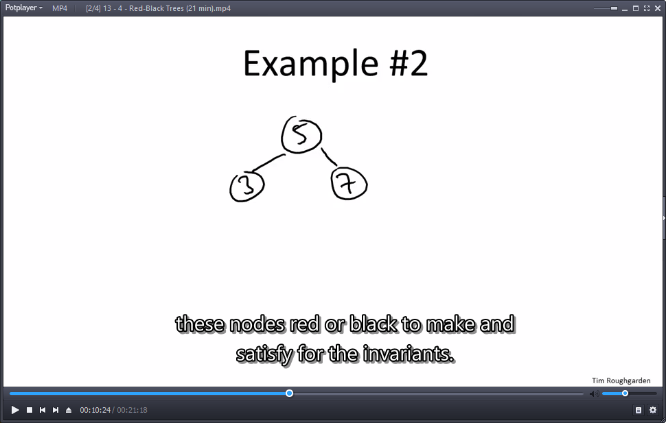 - Good. All invariants are kept.

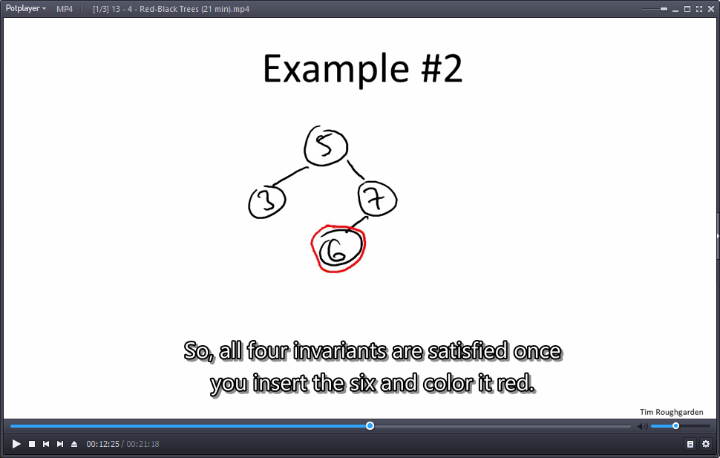 **OR** 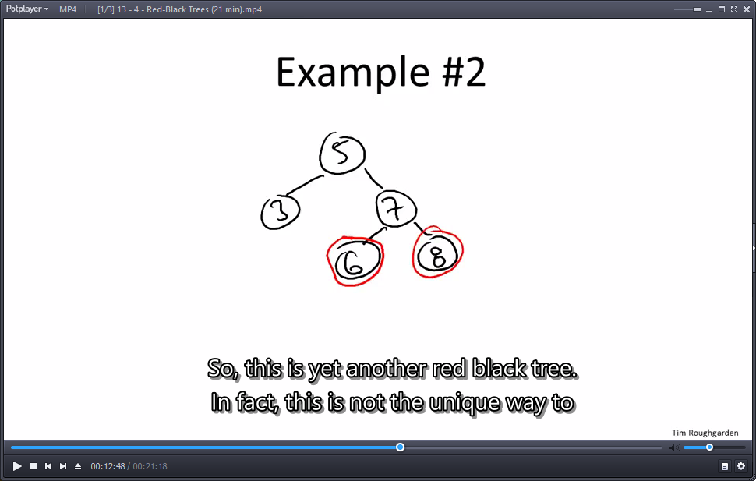- To keep good. Color new children nodes red.

 - **OR** - To keep good: color 7 as red and you’re done.

**Height Guarantee (Red-Black Tree):** no more than double the absolute minimum.

* Claim: every red-black tree with n nodes has height ≤ 
* Proof: **(Observation)** if every root-NULL path has ≥ k nodes, then tree includes (at the top) a perfectly balanced search tree of depth k-1.



* Story so far: size  , where k = minimum # of nodes on root-NULL path
* => 
* Thus: in a red-black tree with n nodes, there is a root-NULL path with at most  black nodes (no reds at all, longer paths must have reds).
* By 4th invariant: every root-NULL path has ≤ black nodes.
* By 3rd invariant: every root-NULL path has ≤total nodes.

**The hard part:** maintaining these invariants. (Insert/Delete)

## 13 - 5 - Rotations [Advanced - Optional] (8 min)

**Rotations:**

* Key primitive: Rotations.

[Common to all balanced search tree implementations: red-black, AVL, B, B+, etc.]

* Idea: Locally rebalance subtrees at a node in O(1) time.
* Left rotation: **[of a parent x and right child y]**



* Right rotation: **[of parent x and left child y]**



**Nice properties:** Searth tree property maintained , can implement in O(1) time.

## 13 - 6 - Insertion in a Red-Black Tree [Advanced] (15 min)

**Insertion in a Red-Black Tree**

**High-Level Plan:**

* Idea for Insert/Delete: Proceed as in a normal binary search tree, then recolor and/or perform rotations until invariants are restored.

**Insert(x):** [red-black tree]

1. Insert x as usual (makes x a leaf)
2. Try coloring x red. (black breaks 4th black-count invariant)
3. If x’s parent y is black, done.
4. Else y is red => y has a black parent w.

* **Case 1:**
* The other child z of x’s grandparent w is also red.

=> recolor y, z black and w red.

[does not break invariant (4)]

=> either restores invariant (3) or propagates the double red upward.

=> can only happen O(logn) times.

[If you reach the root, recolor it black => Preserves invariant (4)]

* **Case 2:**
* Let x, y be the current double-red, x the deeper node. Let w = x’s grandparent. Suppose w’s other child is NULL or is a black node z.
* Exercise/case analysis (details omitted):
* Can eliminate double-red [=> All invariants satisfied] in O(1) time via 2-3 rotations+recolorings.

Overall runtime of Insert is O(log(n))

## Problem Set-5

### Question 1

Consider a directed graph with distinct and nonnegative edge lengths and a source vertex *s*. Fix a destination vertex *t*, and assume that the graph contains at least one *s*-*t* path. Which of the following statements are true? [Check all that apply.]

There is a shortest *s*-*t* path with no repeated vertices (i.e., a "simple" or "loopless" such path). **EX:** a loop makes the path longer.

The shortest (i.e., minimum-length) *s*-*t* path might have as many as *n*−1 edges, where *n* is the number of vertices. **EX:** if it has more, there’s a loop. N-1: chain.

The shortest *s*-*t* path must include the minimum-length edge of *G*. **EX:** that edge doesn’t have to connect s-t. **NO.**

The shortest *s*-*t* path must exclude the maximum-length edge of *G*. **EX:** might be the only edge that connects s-t. **NO.**

### Question 2

Consider a directed graph *G*=(*V*,*E*) and a source vertex *s* with the following properties: edges that leave the source vertex *s* have arbitrary (possibly negative) lengths; all other edge lengths are nonnegative; and there are no edges from any other vertex to the source *s*. Does Dijkstra's shortest-path algorithm correctly compute shortest-path distances (from *s*) in this graph?

Never

Always

Only if we add the assumption that *G* contains no directed cycles with negative total weight. **EX:** there are no return edges to s, so there are no negative cycles.

Maybe, maybe not (depends on the graph)

**EX:**

First iteration of Dijkstra, A[w*]=A[s]+l_sw* (w* reachable from s). This value can be negative, but after this point there are no return values and it is as if we just reduced all the vertex values in a regular non-negative graph by a constant.

### Question 3

Suppose you implement the functionality of a priority queue using a *sorted* array (e.g., from biggest to smallest). What is the worst-case running time of Insert and Extract-Min, respectively? (Assume that you have a large enough array to accommodate the Insertions that you face.)

Θ(*n*) and Θ(1)

Θ(log*n*) and Θ(1)

Θ(*n*) and Θ(*n*)

Θ(1) and Θ(*n*)

**Ex:**

If you get a new biggest value, you have to put it at index 0, and shift all other values.

If you want max/min, you just pluck if off the index[0] or index[len-1].

### Question 4

Suppose you implement the functionality of a priority queue using an *unsorted* array. What is the worst-case running time of Insert and Extract-Min, respectively? (Assume that you have a large enough array to accommodate the Insertions that you face.)

Θ(1) and Θ(log*n*)

Θ(*n*) and Θ(*n*)

Θ(*n*) and Θ(1)

Θ(1) and Θ(*n*)

**Ex:**

Insert – wherever.

Min – requires looking at all items.

### Question 5

You are given a heap with *n* elements that supports Insert and Extract-Min. Which of the following tasks can you achieve in *O*(log*n*) time?

None of these.

Find the median of the elements stored in the heap.

Find the largest element stored in the heap. **EX:** requires looking at all items: O(n)

Find the fifth-smallest element stored in the heap. **EX:** Extract*5: O(logn)

## Programming Question-5

### Question 1

In this programming problem you'll code up Dijkstra's shortest-path algorithm.   
Download the text file [here](http://spark-public.s3.amazonaws.com/algo1/programming_prob/dijkstraData.txt). (Right click and save link as).   
The file contains an adjacency list representation of an undirected weighted graph with 200 vertices labeled 1 to 200. Each row consists of the node tuples that are adjacent to that particular vertex along with the length of that edge. For example, the 6th row has 6 as the first entry indicating that this row corresponds to the vertex labeled 6. The next entry of this row "141,8200" indicates that there is an edge between vertex 6 and vertex 141 that has length 8200. The rest of the pairs of this row indicate the other vertices adjacent to vertex 6 and the lengths of the corresponding edges.  
  
Your task is to run Dijkstra's shortest-path algorithm on this graph, using 1 (the first vertex) as the source vertex, and to compute the shortest-path distances between 1 and every other vertex of the graph. If there is no path between a vertex *v* and vertex 1, we'll define the shortest-path distance between 1 and *v* to be 1000000.   
  
You should report the shortest-path distances to the following ten vertices, in order: 7,37,59,82,99,115,133,165,188,197. You should encode the distances as a comma-separated string of integers. So if you find that all ten of these vertices except 115 are at distance 1000 away from vertex 1 and 115 is 2000 distance away, then your answer should be 1000,1000,1000,1000,1000,2000,1000,1000,1000,1000. Remember the order of reporting DOES MATTER, and the string should be in the same order in which the above ten vertices are given. Please type your answer in the space provided.  
  
IMPLEMENTATION NOTES: This graph is small enough that the straightforward *O*(*mn*) time implementation of Dijkstra's algorithm should work fine. OPTIONAL: For those of you seeking an additional challenge, try implementing the heap-based version. Note this requires a heap that supports deletions, and you'll probably need to maintain some kind of mapping between vertices and their positions in the heap.

**Answer:**

2599,2610,2947,2052,2367,2399,2029,2442,2505,3068

<https://github.com/OferSheffer/Review_Stanford_Algorithms/tree/master/src/P01W05Q01>

# 14 - Week 06 - Hashing - The Basics

## 14 - 1 - Hash Tables_ Operations and Applications (19 min)

**Hash Table: Supported Operations**

Purpose: maintain a (possibly evolving) set of stuff. [Transactions, people + associated data, IP addresses, etc.]

* Insert: add new record [using a “key”]
* Delete: delete existing record
* Lookup: check for a particular record (a “dictionary”)

Amazing guarantee: all operations in O(1) time! *

* 1. Properly implemented, 2. Non-pathological data

**Application: De-Duplication:**

* Given: a “stream” of objects.

[e.g., linear scan through a huge file, or objects arriving in real time]

* Goal: remove duplicates (i.e., keep track of unique objects)

[e.g., report unique visitors to web site, avoid search results duplicates]

* Solution: when new object x arrives
  + Lookup x in hash table H
  + If not found, Insert x into H

**Application: The 2-SUM Problem**

* Input: unsorted array A of n integers. Target sum t.
* Goal: determine whether or not there are two numbers x, y in A with
  + 
* Naïve Solution:  time via exhaustive search
* Better:

1. Sort A ( time)
2. For each x in A, look for t-x in A via binary search ( )

* Amazing:

1. Insert elements of A into hash table H ( time)
2. For each x in A, Loopup t-x ( )

* **Note:** we’re doing repeated lookups on t-x values.

**Further Immediate Applications:**

* Historical application: symbol tables in compilers
* Blocking network traffic
* Search algorithms (e.g., game tree exploration)
  + Use hash table to avoid exploring any configuration (e.g., arrangement of chess pieces) more than once.
* Etc.

## 14 - 2 - Hash Tables_ Implementation Details, Part I (19 min)

**Hash Table: Supported Operations**

* Insert: add new record [using a “key”]
* Delete: delete existing record
* Lookup: check for a particular record (a “dictionary”)

* 1. Properly implemented, 2. Non-pathological data – O(1)

**High Level Idea:**

* Setup: universe U [e.g., all IP addresses, all names, all chessboard configurations, etc.]

[Generally, the universe of all possible configurations is REALLY BIG]

* Goal: want to maintain evolving set 

[Generally, set of reasonable size]

* Naïve Solutions:
  + Array based solution [indexed by u]
    - -O(1) operations but  space
  + List based solution
    - - space, but lookup.
* Solution:
  + Pick n = # of ‘buckets’ with (for simplicity assume |S| doesn’t vary much)
  + Choose a hash function 
  + Use array A of length n, store x in A[h(x)]

**The birthday “paradox”:** consider n people with random birthdays. How large does n need to be before there is at least a 50% chance that two people have the same birthday?



**EX:**

<https://en.wikipedia.org/wiki/Birthday_problem>

Note: For k days, the answer is about the square root of k.

**Resolving Collisions:**

* Collision: distinct  such that 
* Solution 1: **[separate] chaining**
  + Keep linked list in each bucket
  + given a key/object x, perform Insert/Delete/Lookup in list in 
* Solution 2: **open addressing** (only one object per bucket)
  + Hash function now specifies probe sequence 
  + [keep trying till find open slot]
  + Examples: linear probing (look consecutively), double hashing (use 2 hash functions)

## 14 - 3 - Hash Tables_ Implementation Details, Part II (22 min)*

**What makes a good Hash Function?**

* Note: in hash table with chaining, Insert is 
*  for Insert/Delete.
  + Could be anywhere from m/n (equal length lists) to m in the case where all m objects fall in the same bucket.
* Point: performance depends on the choice of hash function!

[Analogous to open addressing – performance governed by length of probe sequence]

Properties of a “Good” Hash function

1. Should lead to good performance => i.e., should “spread data out” (gold standard – completely random hashing)
2. Should be easy to store / very fast to evaluate.

**Bad Hash Functions:** It’s easy to design them.

* Example: keys = phone numbers (10-digits). 
  + Terrible hash function: 
  + Mediocre hash function: 

[Still vulnerable to patterns in last 4 digits]

* Example: keys = memory locations. (will be multiples of a power of 2)
  + Bad hash function: 

=> All odd buckets guaranteed to be empty.

**Quick and Dirty Hash Functions:**

Note: Do more research if you need a hash for super critical code.



How to choose n = # of buckets (when using the modulus compression function)

**Note:** if the date and bucket number share a factor, there’s a good chance to get empty buckets. You want to number of buckets to NOT share factors with the data – primes!

1. Choose n to be a prime (within small constant factor of # of objects in table)
   1. E.g. Lookup a list of known primes for your # of buckets.
   2. If you need millions of buckets, use an algorithm for primality testing.

**Not too close to patterns on the data:** (for example…)

1. Not too close to a power of 2
2. Not too close to a power of 10

**This is not the state of the art in hash functions.** For mission critical code, study further. Build multiple prototypes and compare performance.

# 15 - Week 06 - Universal Hashing

## 15 - 1 - Pathological Data Sets and Universal Hashing Motivation (22 min)

**Universal Hashing – Motivation:**

**Hash Table: Supported Operations:**

* Insert
* Delete (easy with chaining, harder with “open addressing”)
* Lookup

Note: all in O(1) if (1) **properly implemented** and (2) **non-pathological data**.

**The Load of a Hash Table:**

* Definition: the load factor of a hash table is



**Notes:**

* Between open addressing and chaining, only chaining can handle a load larger than 1.
*  is necessary condition for operations to run in constant time.
  + E.g., nlogn items for n buckets => logn time for lookups instead of O(1).
* Open addressing requires 

Upshot 1: good HT performance, need to control load. A lot of items => increase # of buckets.

**Pathological Data Sets:**

Upshot 2: for good HT performance, need a good hash function.

* Ideal: super-clever hash function guaranteed to spread data evenly (amongst buckets).
* Problem: DOESN’T EXIST. Pigeonhole principle. There are at least |U|/n elements for bucket j. If data is only those elements for the same bucket, everything collides.

**Pathological Data in the Real World:**

* Preference: Crosby and Wallach, USENIX 2003.
* Main Point: can paralyze several real-world systems (e.g., network intrusion detection) by exploiting badly designed hash functions. If you exhibit a pathological data-set to the related hash tables, performance devolves away from linear and the system would be broken.
  + How can we come up with a pathological data set?
  + Open Source – you can inspect the code.
  + Overly simplistic hash function (focus on speed)
    - [easy to reverse engineer a pathological data set]

**Solutions:** If there is concern about malicious pathological data-sets.

1. Use a cryptographic hash function (e.g., SHA-2)
   * Infeasible to reverse engineer a pathological data set
2. Use randomization. (next 2 videos)
   * Design a **family** H of hash functions such that for all data sets S, “almost all” functions  spread S out “pretty evenly”. We pick randomly which one to use at runtime.

[Similar to Quick Sort random pivot guarantee, average running time was O(nlogn)]

## 15 - 2 - Universal Hashing_ Definition and Example [Advanced - Optional] (26 min)

**Universal Hash Functions:**

* Definition: Let H be a set of hash functions from U to {0,1,2,…,n-1}

H is universal iff:

For all x,y in U (with )



When h is chosen uniformly at random from H.

[i.e., collision probability as small as with “gold standard” of perfectly random hashing]

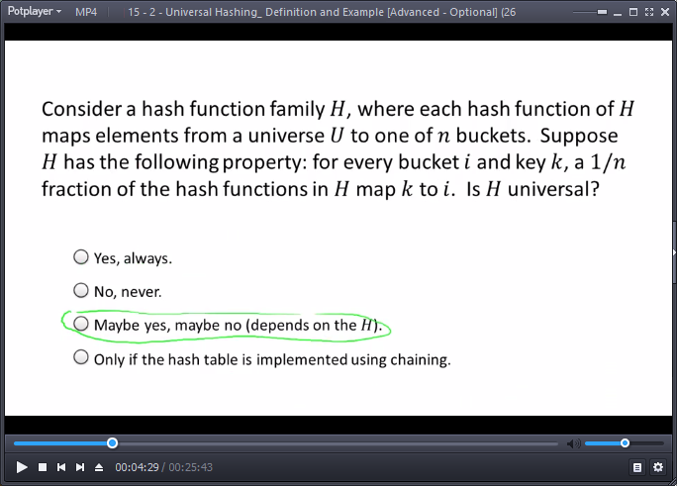

e.g., each h function transfers all k’s to one different bucket. Not universal as x and y will easily collide.

**Example: Hashing IP Addresses**

Usefullness of this ‘universal’ definition: (1) definition is satisfied by objects of interest (e.g., hash functions we’d liked to implement – easy to store and evaluate), (2) something good must happed if we meet the definition. E.g., good performance for hashing.

* Let U = IP addresses (of the form [x1.x2.x3.x4], with each )
* Let n = prime (e.g., small multiple of # of objects in HT)
  + For 500 IPs, we pick n=997. (roughly double items to store)
* Construction: Define one hash function  per 4-tuple  with each  ( such functions)
* Define:  : IP addrs -> buckets by 
  + Set with  hash functions, each meets the criteria: easy to store (only coefficients: 4 numbers), easy to evaluate (a few multiplications and additions, and modulus – O(1) time).

**A Universal Hash Function:**

* Define: 
* 
* Theorem: This family is universal

**Proof**

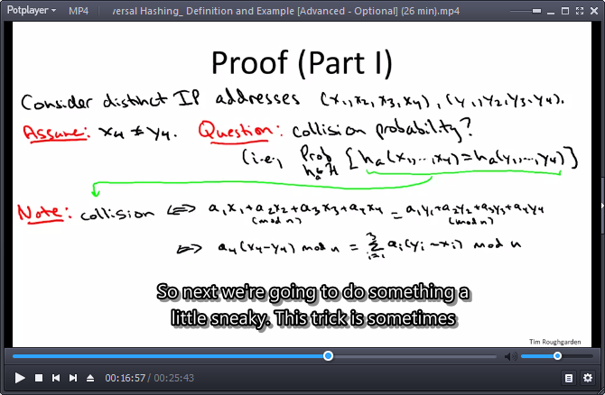

Principle of deferred decisions: instead of flipping a bunch of coins, only flip some.



Everything except a4 if fixed. Note: **n has to be bigger than the largest coefficient a.**

You can always break data into smaller chunks so a small n could be used.

|  |  |  |
| --- | --- | --- |
|  |  | mod n |
| 0 | 0 | 0 |
| 1 | 2, 3 | 2, 3 |
| 2 | 4, 6 | 4, 6 |
| 3 | 6, 9 | 6, 2 |
| 4 | 8, 12 | 1, 5 |
| 5 | 10, 15 | 3, 1 |
| 6 | 12, 18 | 5, 4 |

Note: results are equally likely to be any of {0,1,…,n-1}.

## 15 - 3 - Universal Hashing_ Analysis of Chaining [Advanced - Optional] (19 min)

**Universal Hash Functions: Performance Guarantees (Chaining)**

Universal Hash Functions – H a set of hahs functions from U to {0,1,…,n-1} [n = # of buckets]



When h is chosen uniformly at random from H. (i.e., collision probability per “gold standard”)

**Chaining: Constant Time Guarantee**

* Scenario: hash table implemented with chaining. Hash function h chosen uniformly at random from universal family H. (e.g., as in the above example, randomly choosing 4 a coefficients)
* Theorem (for Universal Hash function): [Carter-Wegman 1979]

All operations run in O(1) time. [for every arbitrary **data set S**]

* Caveats:
  + O(1) in **expectation** over the random choice of the hash function h.
  + Assumes |S|=O(n) [i.e., load ] [n = # number of buckets]
  + Assumes takes O(1) time to evaluate hash function.

**Proof (chaining hash table):** (bound the time of an unsuccessful lookup)





**Recall:**

 , 

By definition of a universal family of hash functions, the smallest valid upper bound on this is: 

Note: L=sum(Zy) – counts the number of items from S that wound up in said bucket.



**Recall: Linearity of Expectation (General Decomposition Principle)**

Express Y which you really care about as sum of indicator random variables:

* 

## 15 - 4 - Hash Table Performance with Open Addressing [Advanced - Optional] (16 min)

**Performance Guarantees (Open Addressing):**

* Recall (Open Addressing):
  + One object per slot, hash function produces a probe sequence for keys.

[linear probing – one hash function, add one until you find an empty slot]

* Fact: difficult to analyze rigorousely.
* Heuristic assumption: [for a quick & dirty idealized analysis only]

Each of the n! probe sequences is equally likely.

**Heuristic Analysis:**

* Observation: under heuristic assumption,
  + expected insertion time is , where  = load.
* Proof: A random probe finds an empty slot with probability 
* So: Insertion time ~ the number N of coin flips to get “heads”, where  .

If N is # of coin flips needed to get “heads” for a coin with “heads” probability of ,

* then  

The value of this proof depends on the open addressing strategy used.

**Linear Probing:** (expect clumping of data)

* Note: heuristic assumption completely false.

You can try to get the E[N] with double hashing, don’t expect it with linear probing.

* Assume instead:

Initial probes uniform at random independent for different keys. (“less false”)

* Theorem: [Knuth 1962] under above assumption, expected insertion time is

 , where = load. E.g.  , then insertion time.

With 90%, it blows up to 100 probes so you want to keep away from high volume.

**Note:** it might appear that linear probing is terrible, but it actually interacts well with memory hierarchies. So, cost and benefits are a subtle trade-offs between different approaches. If you have mission critical code, implement prototypes and figure out which one is best for your particular application.

The allure of Algorithms: D.E. Knuth. The Art of Computer Programming, Volume 3.

# 16 - Week 06 - Bloom Filters

## 16 - 1 - Bloom Filters_ The Basics (16 min)

Why Bloom? – super-fast **Inserts** and **Lookups**. [Burton Bloom 1970]

Nickname: **hash set** (instead of hash table or hash map)

Comparison to Hash Tables:

* Pros: more space efficient.
* Cons:
  + Can’t store an associated object, **only values** (seen/not the object before)
  + **No deletions** (at least not in the basic form)
  + Small **false positive** probability (phantom objects)

[i.e., might say x has been inserted even though it hasn’t been]

**Bloom Filters: Applications**

* Original: early spellcheckers (Insert values, Lookup: is this in the Bloom Filter?)
  + This isn’t a perfect spellchecker, sometimes misspelled words would be missed.
  + This was a ‘win’ 40 years ago.
* Canonical: list of forbidden passwords (weak, easy, common)
  + We don’t care if we get a false positive, [a legit password might be rejected]
* Modern: network routers. [e,g, blocked IP addresses, maintaining cache, statistics/DNS]
  + Limited memory, need to be super-fast

**Bloom Filter: Under the Hood**

* Ingredients: each entry in the array can only take one bit {0,1}
  + Array of n bits (so  = # of bits per object in data set S)

[Imagine  bits/item – e.g., impressivly efficient for IP storage (32bits)]

* + k hash functions  (k = small constant): have we seen this before or not?

k – small constant, e.g., 3, 4, 5. Multiple hash functions - a tad complicated.

Note: typically, it is enough to use just 2 different hash functions and generate k different linear combinations of those hash functions.

* **Insert(x):**
  + for i = 1, 2, …, k:

set  [whether or not bit already set to 1]

[set k bits equal to 1]

* **Lookup(x):** return TRUE ⬄ for every i=1,2,…,k.
* Note: no false negatives. (if x was inserted, Lookup(x) guaranteed to succeed)
* But: false positive possible - if all k ‘s already set to 1 by other insertions.

e.g, k=3, consider IP address #1, relevant bits are 17,23,36. Maybe we never inserted this IP, but we have inserted IP #2, and in its insertion, bit 17 got set to 1, other IP addressed activated bits 23 and 36. Thus, a query for IP#1 would come up positive despite it not being inserted.

**Is this useful?** We hope error probability will be small even when space per object is small.

## 16 - 2 - Bloom Filters_ Heuristic Analysis (13 min)

**Heuristic Analysis (Bloom Filters):**

* Intuition: should be a trade-off between space and error (false positive) probability.
* Assume: [not justified] all ‘s uniformly random and independent (across different i’s and x’s).
* Setup: n bits, insert data set S into bloom filter.

Note:

* For each bit of the populated A, the probability it’s been set to 1 is (under above assumption): 



Note: cyan function is 1+x, purple function is e^x. If x=-1/n, we get the inequality presented.

Note 2: 1/n is close to 0, so instead of inequality, it should be ‘’.

New value**: ‘b’ = # of bits per object (n/|S|).** (k = number of hash functions)

So, chance for a bit to be populated is:



If we use **large ‘b’**, i.e., many bits per object, this expression goes down to 0, lowering the changes for a false positive.

**Heuristic Analysis (con’d)**

Under assumption, for **x (and its k bits) not in S**, false positive probability is 

How to set k? for fixed b,  is minimized by setting: 

i.e. the number of required hash functions is scaling linearly with the number of bits used per object.

Plugging this k back in…



**Ex:** with b=8 (8bits per object), choose k=5 or 6 (hash functions), error probability only approximately 2% (pretty good). If we double the number of bits, to 16, the error probability would go down to around 1/5000.

## Problem Set-6

### Question 1

Suppose we use a hash function *h* to hash *n* distinct keys into an array *T* of length *m*. Assuming simple uniform hashing --- that is, with each key mapped independently and uniformly to a random bucket --- what is the expected number of keys that get mapped to the first bucket? More precisely, what is the expected cardinality of the set {*k*:*h*(*k*)=1}.

*n*/*m*

1/*n*

1/*m*

*m*/*n*

*n*/(2*m*)

*m*/(2*n*)

**Ex:**

There are n keys mapped into length m. Each key mapped randomly into 1/m. Thus, a total of n/m is the load , as well as the expected average cardinality in each slot.

### Question 2

You are given a binary tree (via a pointer to its root) with *n* nodes, which may or may not be a binary search tree. How much time is necessary and sufficient to check whether or not the tree satisfies the search tree property?

Θ(*n*)

Θ(*n*log*n*)

Θ(*height*)

Θ(log*n*)

**Ex:**

Note 1: it is unstated that the tree is/isn’t balanced. Reminder ‘search tree property’ – each node has smaller keys on its left, and larger keys on its right. To check this, you can go one by one over the entire n items, for each checking its 2 (or less) children. O(n)

Example implementation is DFS or BFS, taking O(m+n), where in this case  . O(n)

### Question 3

You are given a binary tree (via a pointer to its root) with *n* nodes. As in lecture, let size(x) denote the number of nodes in the subtree rooted at the node x. How much time is necessary and sufficient to compute size(x) for every node x of the tree?



Θ(*n*log*n*)

Θ(*n*)

Θ(*height*)

**Ex:**

Note 1: no indication if tree is/isn’t balanced. DFS or BFS, taking O(m+n), where in this case  . O(n)

### Question 4

Which of the following is *not* a property that you expect a well-designed hash function to have?

The hash function should "spread out" most (i.e., "non-pathological") data sets (across the buckets/slots of the hash table). **Expected.**

The hash function should be easy to store (constant space or close to it). **Expected.**

The hash function should be easy to compute (constant time or close to it). **Expected.**

The hash function should "spread out" every data set (across the buckets/slots of the hash table). **Not.** **Ex:** Every hash, from the pigeonhold principle will have pathological test.

### Question 5

Suppose we relax the third invariant of red-black trees to the property that there are no *three* reds in a row. That is, if a node and its parent are both red, then both of its children must be black. Call these *relaxed* red-black trees. Which of the following statements is ***not*** true?

There is a relaxed red-black tree that is not also a red-black tree. **True.**

Every red-black tree is also a relaxed red-black tree. **True.**

Every binary search tree can be turned into a relaxed red-black tree (via some coloring of the nodes as black or red). **Not. Ex:** an unbalanced tree will fail invariant 4.

The height of every relaxed red-black tree with *n* nodes is *O*(log*n*). **True.**

**Ex:**

Reminder – 3rd invariant of red-black trees: “No 2 reds in a row”. Now, not **three**.

1. With only one red, a balanced tree with a third level with one leaf had to have that leaf be red colored while the full level two was black (red-black invariant 4: every root-NULL path has same 3 of blacks). Now, level 2 can be all red.
2. Maintains updated invariant 3.
3. An unbalanced tree will fail invariant 4.
4. Limited by x3 for the longest path compared with shortest.

## Programming Question - 6

<https://class.coursera.org/algo-009/quiz?quiz_type=homework>

### Question 1

Download the text file [here](https://d396qusza40orc.cloudfront.net/algo1%2Fprogramming_prob%2F2sum.txt). (Right click and save link as).  
  
The goal of this problem is to implement a variant of the 2-SUM algorithm (covered in the Week 6 lecture on hash table applications).

The file contains 1 million integers, both positive and negative (there might be some repetitions!).This is your array of integers, with the *ith* row of the file specifying the *ith* entry of the array.

Your task is to compute the number of target values *t* in the interval [-10000,10000] (inclusive) such that there are *distinct* numbers *x*,*y* in the input file that satisfy *x*+*y*=*t*. (NOTE: ensuring distinctness requires a one-line addition to the algorithm from lecture.)  
  
Write your numeric answer (an integer between 0 and 20001) in the space provided.

OPTIONAL CHALLENGE: If this problem is too easy for you, try implementing your own hash table for it. For example, you could compare performance under the chaining and open addressing approaches to resolving collisions.

**Answer for Question 1**

### Question 2

Download the text file [here](http://spark-public.s3.amazonaws.com/algo1/programming_prob/Median.txt).  
  
The goal of this problem is to implement the "Median Maintenance" algorithm (covered in the Week 5 lecture on heap applications). The text file contains a list of the integers from 1 to 10000 in unsorted order; you should treat this as a stream of numbers, arriving one by one. Letting *xi* denote the *i*th number of the file, the *k*th median *mk* is defined as the median of the numbers *x*1,…,*xk*. (So, if *k* is odd, then *mk* is ((*k*+1)/2)th smallest number among *x*1,…,*xk*; if *k* is even, then *mk* is the (*k*/2)th smallest number among *x*1,…,*xk*.)  
  
In the box below you should type the sum of these 10000 medians, modulo 10000 (i.e., only the last 4 digits). That is, you should compute (*m*1+*m*2+*m*3+⋯+*m*10000) mod 10000.  
  
OPTIONAL EXERCISE: Compare the performance achieved by heap-based and search-tree-based implementations of the algorithm.

**Answer for Question 2**

Review notes:

* Bucketing in sorting: Bucket sort, Counting sort, Radix sort.
* Map-reduce / Hadoop (automated processing of large data-sets)

[Red-Black Trees: see also AVL trees, splay trees, B trees, B plus trees]

* Hash function design (new stuff), open-addressing, probing strategies, coding multiple prototypes and seeing which one works the best.